

Block Chain Development

Assignment # 1
GoofyCoin Blockchain Development
Submitted By:
Muhammad Mohsin Iqbal (027)
Course:
Block Chain Development
Program:
BS Cr (Digital Forensic & Cyber Security)
Submitted To:
Sir Muhammad Haseeb Zia
University:
Lahore Garrison University
Department:
Department of Criminology
Submission Date: 23-10-2026
GOOFYCOIN
Blockchain Cryptocurrency and Socket ClientServer System

Table of Contents
1. Abstract 3
2. Assignment Objectives 3
3. GoofyCoin File Hierarchy 4
3.1 Project Structure 5
4. System Hierarchy / Architecture 6
4.1 Hierarchy Explanation 6
4.2 Working Sequence 7
5. Overall Workflow 8
5.1 Step-by-Step Workflow 8
5.2 Workflow Diagram 9
6. Core Functions Explained 9
6.1 Function Execution Hierarchy 11
7. Cryptography and Block Structure 11
7.1 ECDSA key pair 11
7.2 Canonical JSON 11
7.3 SHA-256 and hash linkage 12
7.4 Main block fields 12
8. Client–Server Communication 12
9. Error Handling and Security Checks 13
10. Important Implementation Notes 13
11. Test Plan and Expected Evidence 13
12. Screenshot Collection Guide 14
Screenshot : VS Code Startup 14
Screenshot 1: VS Code Startup 14
Screenshot 2 : Create the Python Files 15
Screenshot 3 : GoofyCoin_Server.py Code Startup 16
Screenshot 4 : GoofyCoin_Client.py Code Startup 16
Screenshot 5: Server Terminal Startup 17
Screenshot 6: Client Terminal Startup 18
Screenshot : CreateUser 18
Screenshot 7: Client Admin Login 18
Screenshot 8: GoofyCoin Admin Dashboard 19
Screenshot 9: Normal Create Users 20
Screenshot 10: Normal User Dashboard 21
Screenshot : CreateCoin 22
Screenshot 11: Minting New GoofyCoins 22
Screenshot 12: Successful Coin Minting 22
Screenshot 13: Cryptographic Proof of Successful Coin Minting 23
Screenshot 14: Successful Coin Minting and Updated Admin Balance 24
Screenshot : TransferCoin 24
Coin Purchase Request and TransferCoin Workflow 24
Screenshot : Admin-to-User Coin Transfer 24
Screenshot : User-to-User Coin Transfer 30
Screenshot : Verify_chain 33
Screenshot 27: Viewing Blockchain Ledger and Transaction History 33
Screenshot 28: Blockchain Integrity Verification 35
Screenshot : start_server 36
Screenshot 29: start_server() Function Server Initialization 36
Screenshot 30: Server-Side Client Activity Logging 37
Screenshot : handle_client 38
Client-Side Working and VS Code Setup 38
Screenshot 31: handle_client() Function — Client–Server Communication 38
13. How to Run in Visual Studio Code 39
14. Conclusion 39

1. Abstract
GoofyCoin is a simplified blockchain-based cryptocurrency implemented in Python. The submitted project is split into a server program and an interactive client wallet. The server maintains user records, coin ownership, transaction blocks, cryptographic signatures, and a chain-verification routine. The client sends JSON requests through a TCP socket and displays wallet balances, transaction proof, coin requests, and verification results. The server code uses the ECDSA SECP256k1 curve and SHA-256 hashing to demonstrate digital signatures and hash-linked blocks.
This report explains the submitted code structure and provides screenshot placeholders. Screenshots must be captured from the student’s own VS Code run; no test output is claimed as verified in this report.

2. Assignment Objectives
- Generate users with ECDSA public/private key pairs and unique wallet identifiers.
- Record authorized coin creation and transfers in a blockchain ledger.
- Prevent a user from transferring a coin that belongs to someone else.
- Link blocks with previous hashes and verify digital signatures.
- Create a TCP socket server that accepts client requests.
- Use a client wallet to send requests and display server responses.
- Handle invalid requests and common runtime/network errors.

3. GoofyCoin File Hierarchy
The GoofyCoin project consists of two main Python files and several libraries that support networking, cryptographic operations, data serialization, and concurrent client handling.
File / Component | Role
Server Python File (GoofyCoin_Server.py) | Maintains the shared blockchain state, registers users, creates and transfers coins, verifies the blockchain, accepts TCP connections, and processes client JSON requests.
Client Python File (GoofyCoin_Client.py) | Connects to the server, provides separate Admin and Normal User dashboards, sends JSON requests, and displays wallet balances, transactions, ledger information, and verification results.
Python Package: ecdsa | Provides SigningKey, VerifyingKey, and SECP256k1 for generating cryptographic keys, signing transactions, and verifying digital signatures.
Python Standard Library: socket | Creates TCP sockets for server listening and client-server communication.
Python Standard Library: hashlib | Computes SHA-256 hashes to support transaction integrity and blockchain hash generation.
Python Standard Library: json | Serializes client requests and server responses into JSON format for communication.
Python Standard Library: threading | Allows the server to handle accepted client connections using separate worker threads.
Python Standard Library: datetime | Supports timestamps used to record transaction dates and times.
Python Standard Library: sys | Handles command-line arguments and supports console input/output configuration in the client.

3.1 Project Structure
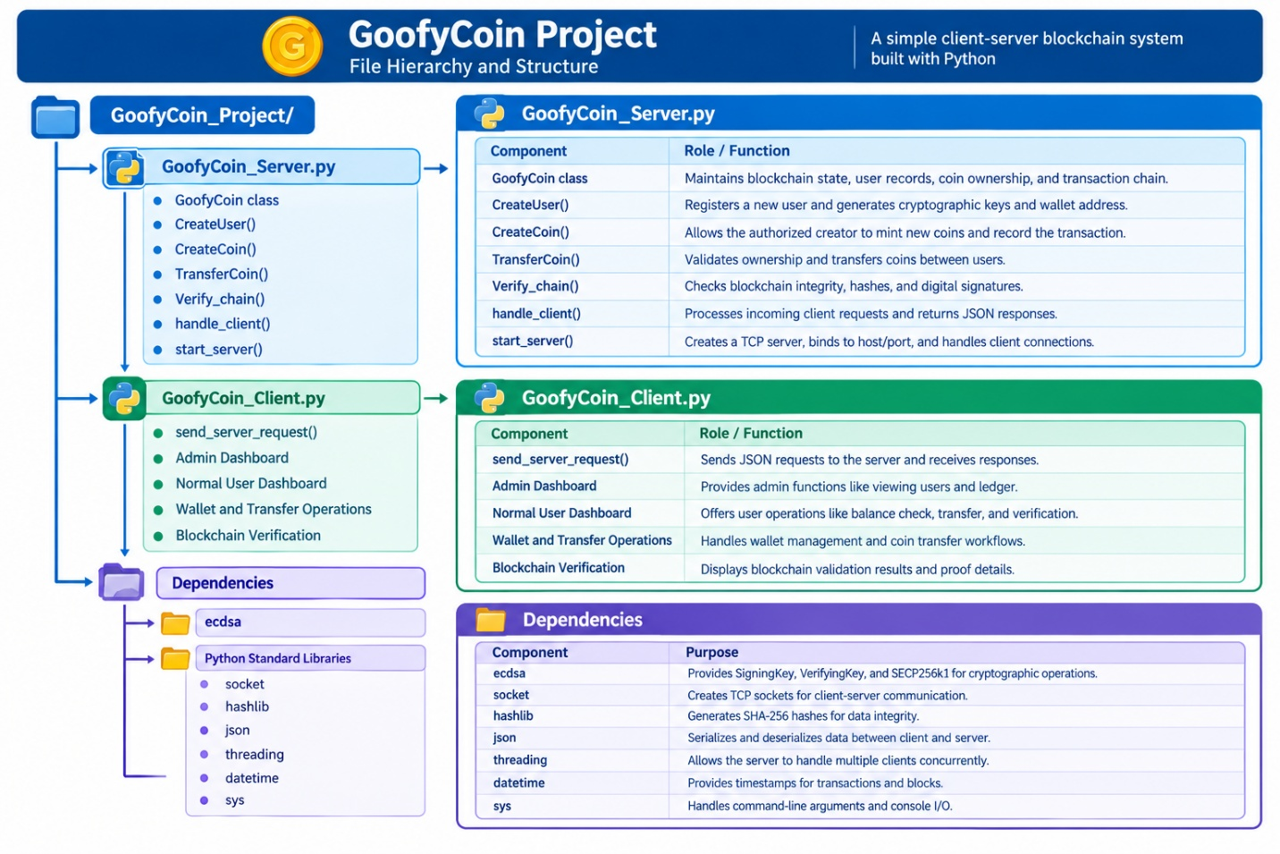

4. System Hierarchy / Architecture
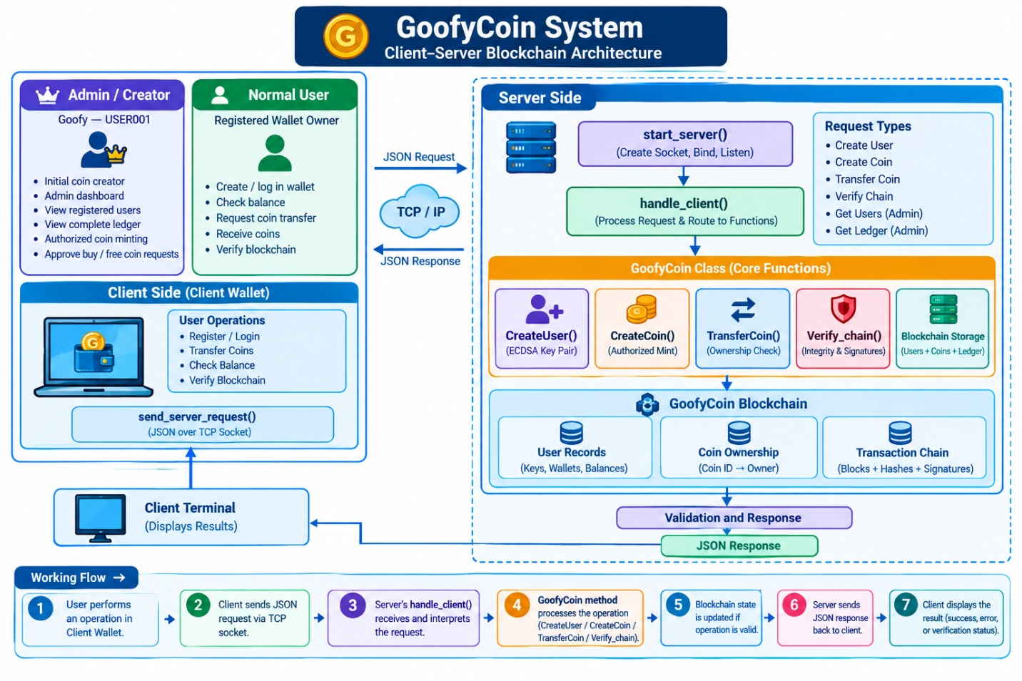

4.1 Hierarchy Explanation
The following table explains the main components of the GoofyCoin system, including the difference between the Admin/Creator and a Normal User.
Component | Function
Admin / Creator (Goofy USER001) | The system's initial coin creator. Accesses the Admin Dashboard and can view registered users, inspect the complete blockchain ledger, and perform authorized coin-minting operations.
Normal User | Registers or accesses a wallet, checks their balance, requests coin transfers, receives coins, and verifies the blockchain.
Client Wallet | Provides the interface through which the admin and normal users interact with the GoofyCoin system. The available dashboard depends on the user's role.
send_server_request() | Sends client requests to the server through a TCP socket using JSON and receives the server's response.
start_server() | Creates the server socket, binds it to the configured host and port, and listens for client connections.
handle_client() | Receives client requests, identifies the requested action, invokes the relevant operation, and returns a JSON response.
CreateUser() | Generates a user's ECDSA key pair and creates wallet-related user information.
CreateCoin() | Creates a coin-minting transaction authorized by the coin creator.
TransferCoin() | Checks coin ownership and validates a transfer request before updating ownership.
Verify_chain() | Checks blockchain integrity, transaction history, and cryptographic signatures.
Admin User Management (GET_USERS) | Retrieves registered-user information for the Admin Dashboard.
Admin Ledger Management (GET_LEDGER) | Retrieves the blockchain ledger, including transaction records, for administrative inspection.
Blockchain State | Maintains user records, coin ownership, coin details, and the transaction chain.
Important note: The client code routes Goofy (USER001) to the Admin Dashboard and other registered users to the User Dashboard. Server-side authorization must also be enforced to ensure that normal users cannot access admin-only operations.

4.2 Working Sequence
- User Selection: The client provides options to access the Admin Dashboard as Goofy (USER001) or create/access a normal user wallet.
- User Operation: The admin or normal user selects an available operation from their dashboard.
- Request Transmission: The client converts the request into JSON and sends it to the server using a TCP socket.
- Request Processing: The server's handle_client() function receives the request and identifies the requested action.
- Function Execution: The appropriate GoofyCoin method processes the request, such as CreateUser(), CreateCoin(), TransferCoin(), or Verify_chain(). Administrative requests can retrieve users or ledger information.
- Blockchain Validation: The system validates the relevant operation and updates blockchain state when appropriate.
- Response and Display: The server returns a JSON response, and the client displays the result, such as a successful transfer, an error message, or blockchain verification status.
- The GoofyCoin system follows a client-server workflow in which the server manages the blockchain, while the client provides separate interfaces for the Admin/Creator and Normal Users.

5. Overall Workflow
The GoofyCoin system follows a client-server workflow in which the server manages the blockchain, while the client provides separate interfaces for the Admin/Creator and Normal Users.

5.1 Step-by-Step Workflow
1. Start the Server: The server creates a GoofyCoin object, initializes the creator account, and prepares the initial blockchain state, including the genesis transaction.
2. Initialize the TCP Server: The server binds to 127.0.0.1 on port 5000 and listens for incoming client connections.
3. Start the Client Wallet: The client is launched in another terminal. The user selects an operation from the appropriate dashboard.
4. Send a Request: When an operation is selected, the client opens a TCP connection and sends a JSON request containing the action and required information.
5. Process the Request: The server's handle_client() function receives the request, identifies the requested action, and calls the relevant GoofyCoin method.
6. Validate and Update: For a valid transaction, the system records the signed transaction in the blockchain and updates the current coin ownership information. Invalid requests return an error response.
7. Display the Result: The server sends a JSON response to the client. The client displays the operation's result, including transaction identifiers and available cryptographic proof fields.
8. Verify the Blockchain: When the user selects the VERIFY action, the server executes Verify_chain() to validate the chain and returns a verification summary.

5.2 Workflow Diagram
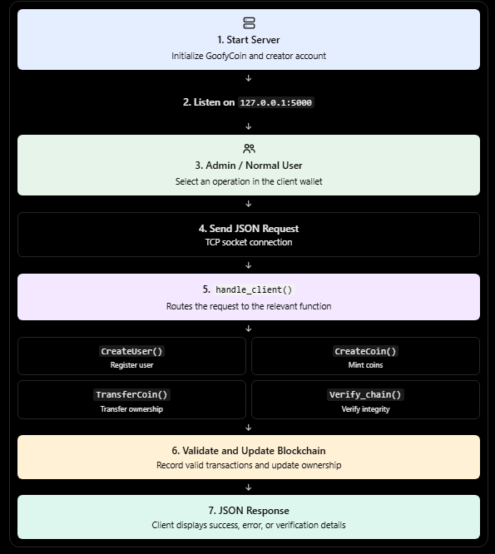

6. Core Functions Explained
The GoofyCoin system uses core functions to manage user identities, coin creation, coin transfers, blockchain verification, and client-server communication.
Function | What It Does | Why It Matters
CreateUser(username) | Validates the username, assigns a sequential user ID, generates an ECDSA private and public key pair, derives a GFC wallet address from the public-key hash, and stores the user record. | Gives each user a cryptographic identity that can be used for transaction signing and signature verification.
CreateCoin(creator, coin_id, coin_name, amount) | Identifies the creator, checks whether the creator is the authorized Goofy / USER001 account, records a signed MINT transaction, and updates coin ownership. | Ensures coin creation is associated with the authorized issuer.
TransferCoin(sender, recipient, coin_id_or_amount) | Checks that both users exist and are different. Accepts a coin ID or amount, checks availability and ownership, signs the transfer transaction, records it in the chain, and updates coin ownership. | Helps prevent users from transferring coins they do not own or coins that are unavailable.
Verify_chain() | Checks the blocks' previous-hash links, verifies signatures using public keys, recalculates block hashes, and replays ownership history. | Helps detect tampering, invalid signatures, broken hash links, and inconsistent ownership history.
start_server(host, port) | Creates a TCP socket, enables address reuse, binds to the configured address, listens for connections, accepts clients, and starts a worker thread for each connection. | Makes the blockchain functionality available to client programs over the network.
handle_client(conn, address, blockchain) | Handles a client connection, reads and interprets requests, routes actions to the appropriate functions, sends JSON results, reports errors, and closes the connection. | Separates network communication from the core blockchain logic and allows client requests to be processed.

6.1 Function Execution Hierarchy
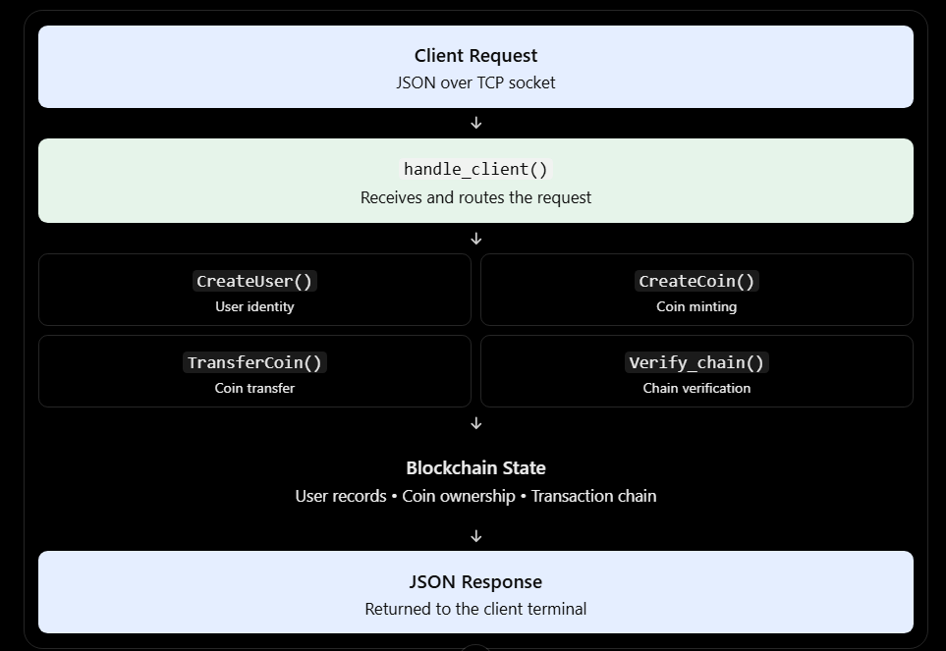Note: start_server() initializes and runs the server, while handle_client() processes incoming client requests. The core GoofyCoin methods perform the corresponding blockchain operations.

7. Cryptography and Block Structure

7.1 ECDSA key pair
CreateUser uses SigningKey.generate(curve=SECP256k1) to generate a private signing key. The corresponding public key is obtained with get_verifying_key(). The private key signs transaction data; the public key verifies the signature. The private key must be kept secret.

7.2 Canonical JSON
The canonical_json helper serializes a transaction with sorted keys and compact separators. This makes the same transaction dictionary produce consistent bytes before signing and hashing.

7.3 SHA-256 and hash linkage
The sha256 helper computes a SHA-256 digest. Each recorded transaction stores the previous block hash, a timestamp, a digital signature, and a calculated block hash. A later block refers to the previous block hash, creating a linked sequence.

7.4 Main block fields
Field | Meaning
index | Position of the block in the chain; the first block has index 0.
transaction | Transaction data, such as type, coin IDs, sender, recipient, amount, and timestamp.
signer | Username whose private key signed the transaction.
signature | ECDSA signature encoded as hexadecimal text.
previous_hash | Hash of the preceding block, or 64 zeroes for the first block.
block_hash | SHA-256 digest derived from the canonical transaction, signature bytes, and previous hash.

8. Client–Server Communication
The client and server use TCP sockets. The client sends JSON followed by a newline. The server’s handler processes an action and sends a JSON response. The submitted client uses send_server_request() for normal request/response actions. The client and server are configured with HOST = 127.0.0.1 and PORT = 5000, so they are intended to run on the same computer unless the configuration is changed.
Example action | Purpose
REGISTER | Create or retrieve a user account.
MINT | Request coin creation by the authorized creator.
TRANSFER | Transfer coins between users.
BALANCE | Retrieve a wallet balance and transaction history.
VERIFY | Run blockchain integrity checks.
GET_USERS / GET_LEDGER | Retrieve registered users or ledger information for display.
ACQUIRE_COIN / APPROVE_REQUEST | Create and approve coin acquisition requests in the client wallet workflow.

9. Error Handling and Security Checks
CreateUser rejects an empty or invalid username and avoids creating a duplicate username.
CreateCoin rejects unknown creators and users who are not authorized to mint.
TransferCoin rejects unknown users, self-transfers, non-existent coins, insufficient balances, and attempts to transfer a specific coin owned by another user.
The server catches exceptions in its client handler and attempts to close the connection safely.
The client handles a refused connection by explaining that the server is not reachable.
Verify_chain reports separate results for structure, hashes, signatures, ownership, transaction history, and tampering.

10. Important Implementation Notes
The code’s introductory comments describe a fixed supply of 1,000 coins. In the server code shown, the genesis setup allocates 1,000 coins to Goofy. However, the visible CreateCoin implementation does not clearly reject a mint request that would take total supply above MAX_COIN_SUPPLY; its amount loop increments coin_count and creates additional IDs. Therefore, the fixed-supply claim should not be described as fully enforced until a supply-cap check is added and tested.
The code stores private keys in the server’s in-memory user records and the client’s output functions can display a private key. This is acceptable only as a classroom demonstration, not as a production wallet design. A real system must never expose private keys in normal output and should protect key storage.
The blockchain state is held in memory. Unless persistence is implemented elsewhere, restarting the server recreates the blockchain and users rather than loading a durable ledger from disk.

11. Test Plan and Expected Evidence
Run each test yourself and insert the actual screenshot in the matching placeholder below. Do not use a mock screenshot or type a result that did not appear in your terminal. Record whether each test passed after you run it.

Test ID | Test case | Expected behavior | Result
T1 | Start the server | Server shows its host, port, listening status, and initial supply/balance. | To be completed after run
T2 | Register a new user | A user ID, wallet address, and public key are returned. | To be completed after run
T3 | Perform an authorized transfer | A successful transaction response includes block/hash/signature information where provided. | To be completed after run
T4 | Attempt to transfer a coin owned by another user | The transfer is rejected and ownership remains unchanged. | To be completed after run
T5 | Verify the blockchain | The client displays the chain verification status and individual checks. | To be completed after run
T6 | Request more than the fixed supply | The request should be rejected if the 1,000-coin limit is implemented; verify this test because a cap check appears missing in the submitted CreateCoin code. | To be completed after run

12. Screenshot Collection Guide

Screenshot : VS Code Startup

Screenshot 1: VS Code Startup
Explanation: In this step, we open the GoofyCoin project folder in Visual Studio Code and install the required ecdsa Python library using python -m pip install ecdsa. The terminal confirms that the library and its dependency are already installed, so the project is ready for the next setup step.

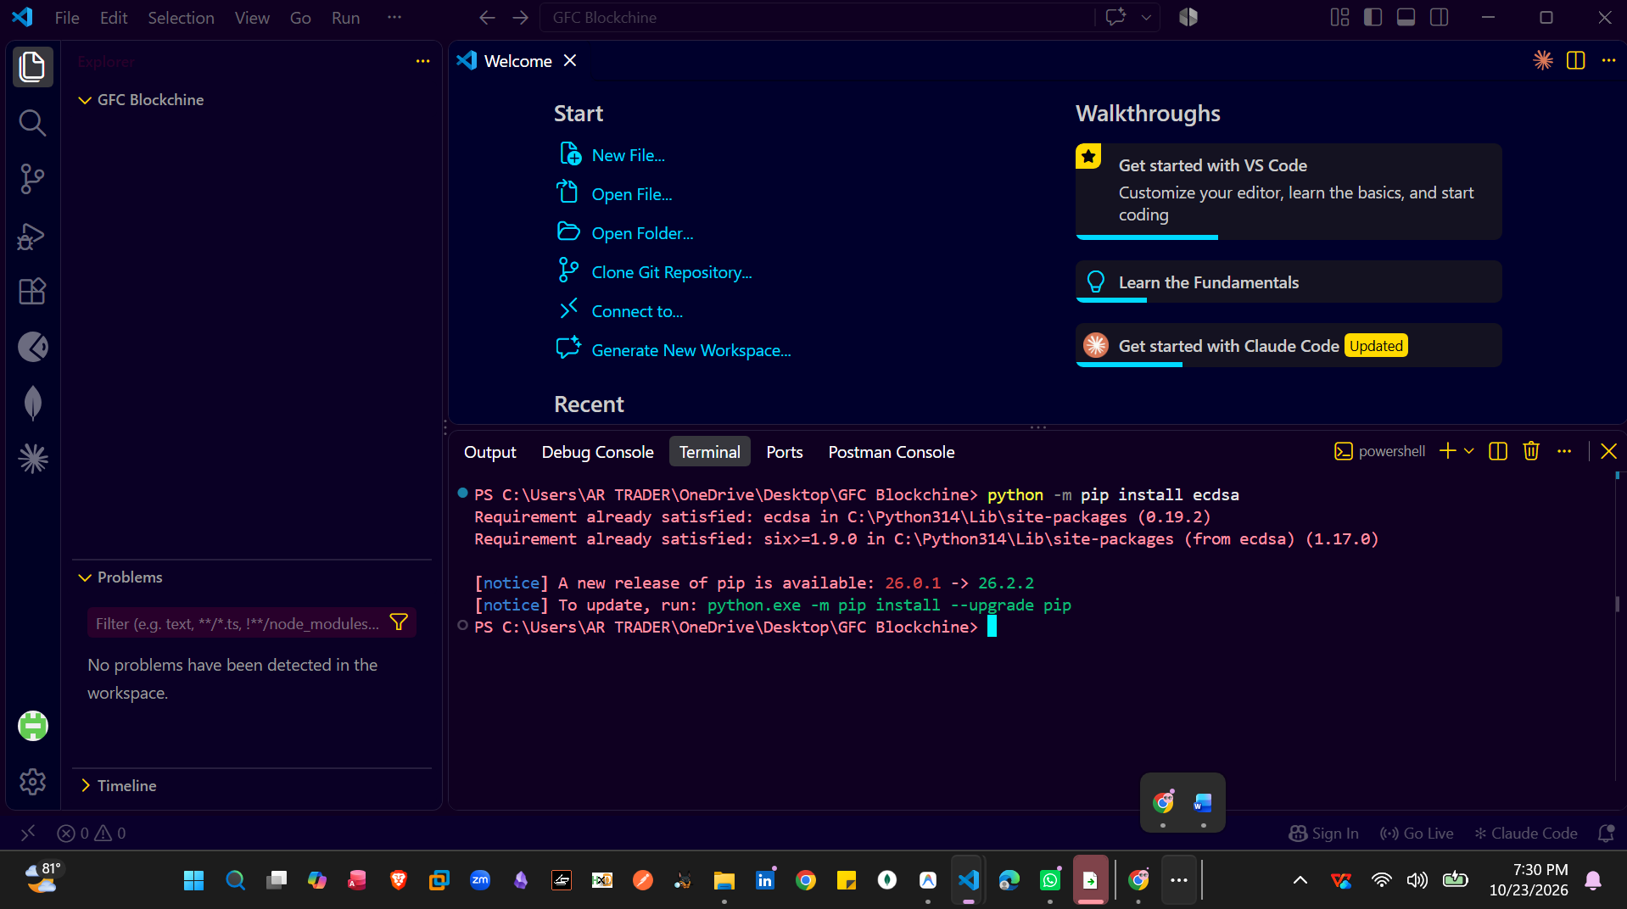

Screenshot 2 : Create the Python Files
Explanation: In this step, we create the required Python files for the GoofyCoin project in Visual Studio Code: GoofyCoin_Server.py and GoofyCoin_Client.py. The server file will manage blockchain operations and client requests, while the client file will provide the user interface for wallet and transaction operations.
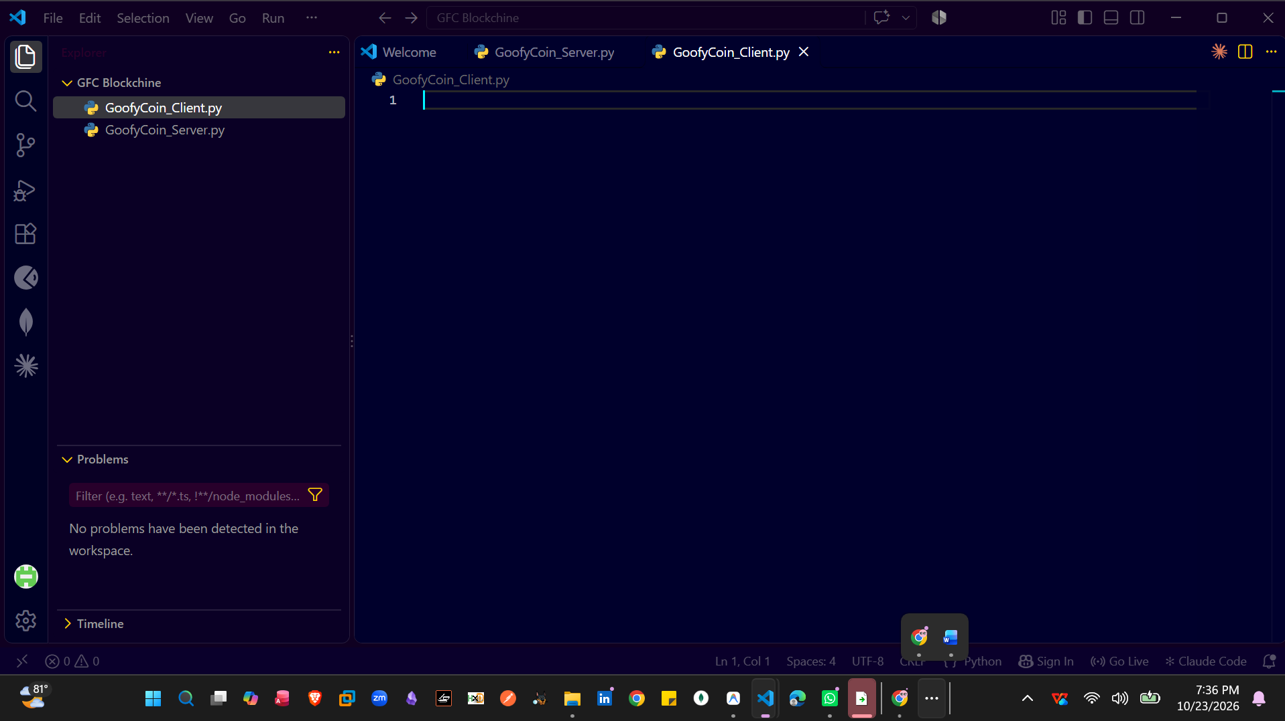

Screenshot 3 : GoofyCoin_Server.py Code Startup
Explanation: In this step, we write and initialize the server-side code in GoofyCoin_Server.py. This file manages user creation, coin creation, transfers, blockchain verification, and client connections.
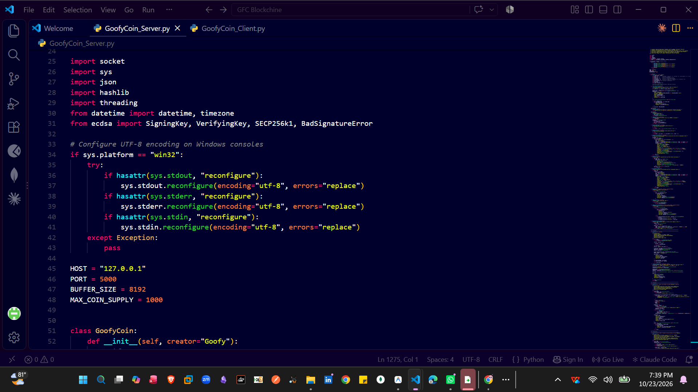

Screenshot 4 : GoofyCoin_Client.py Code Startup
Explanation: This screenshot shows the client-side Python file in Visual Studio Code, where the client interface and request-handling functions are implemented. The file manages Admin and Normal User dashboards, wallet operations, coin transfers, and blockchain verification through communication with the server.
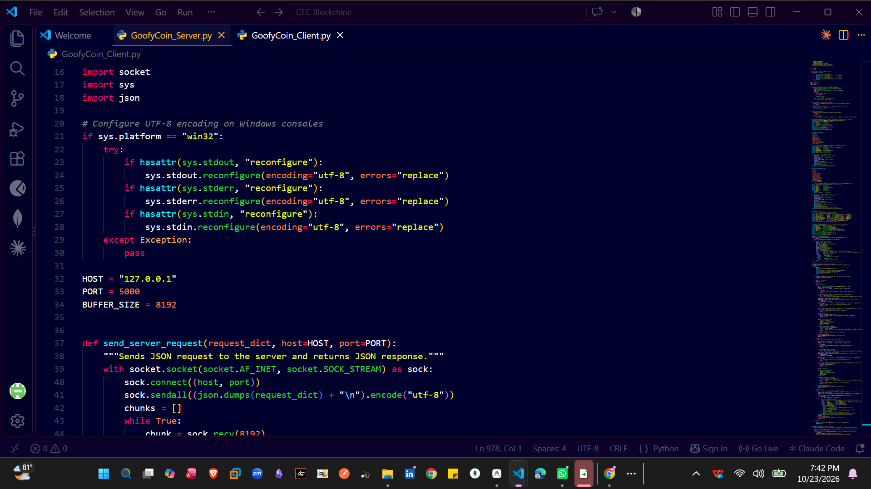

Screenshot 5: Server Terminal Startup
Explanation: In this step, we run GoofyCoin_Server.py in the VS Code terminal to start the GoofyCoin server. The server initializes the blockchain and listens for incoming client connections on the configured host and port.
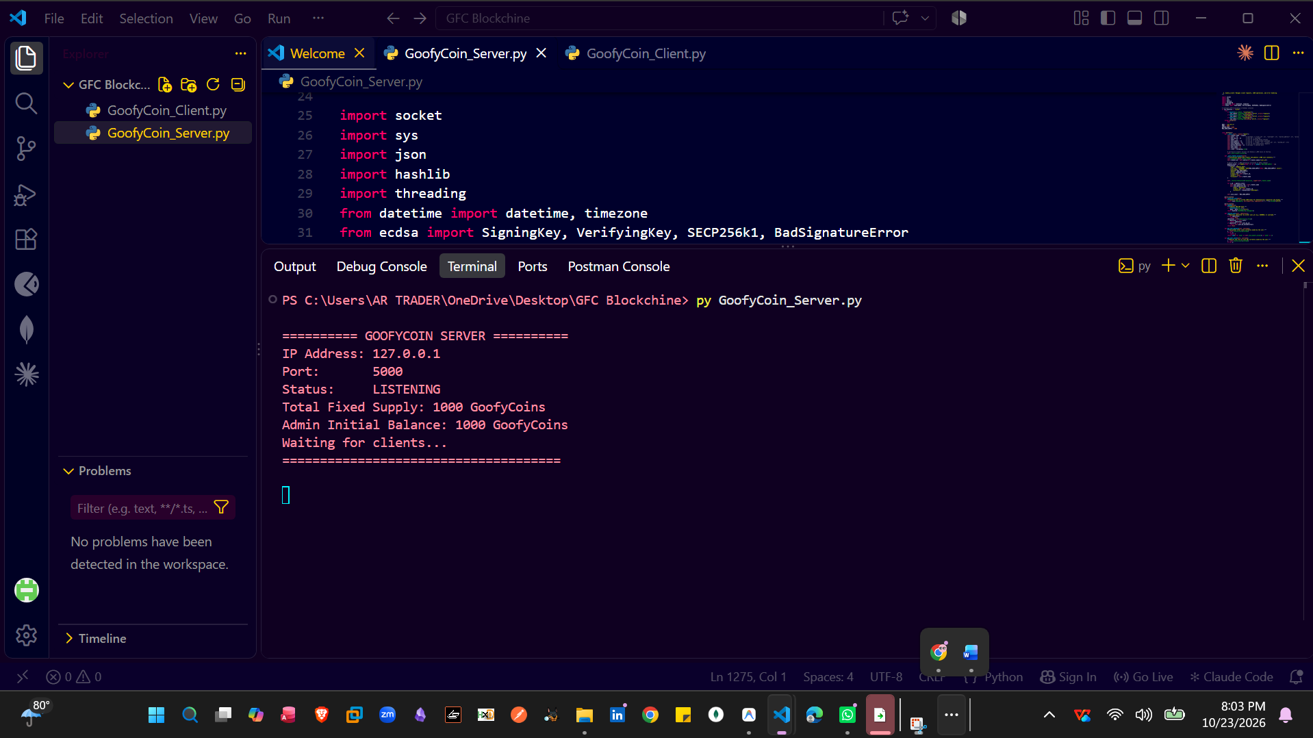

Screenshot 6: Client Terminal Startup
Explanation: In this step, we run GoofyCoin_Client.py in a separate VS Code terminal while the server is running. The client connects to the server and displays the menu for accessing user dashboards, wallet operations, coin transfers, and blockchain verification.
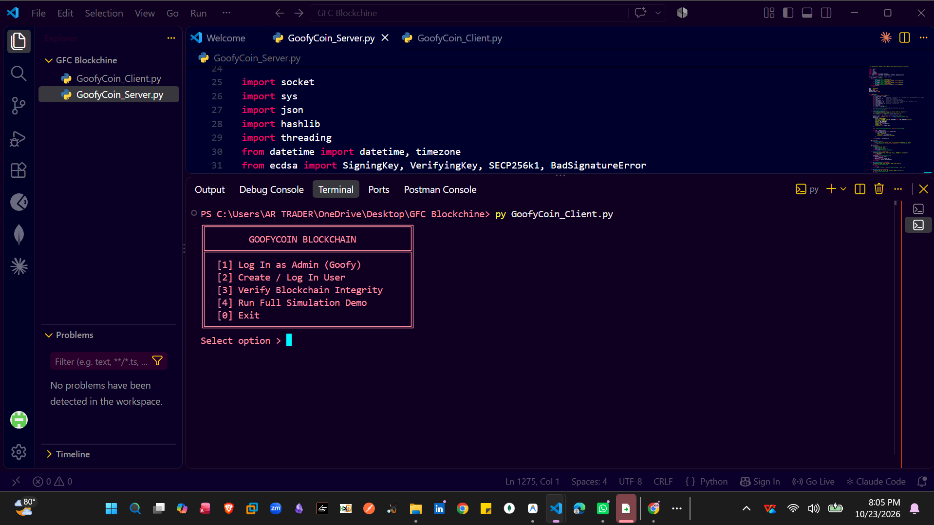

Screenshot : CreateUser

Screenshot 7: Client Admin Login
Explanation: In this step, we log in to the GoofyCoin client using the Admin/Creator account. The Admin Dashboard provides access to administrative features, such as viewing registered users, checking the ledger, and managing authorized coin creation.
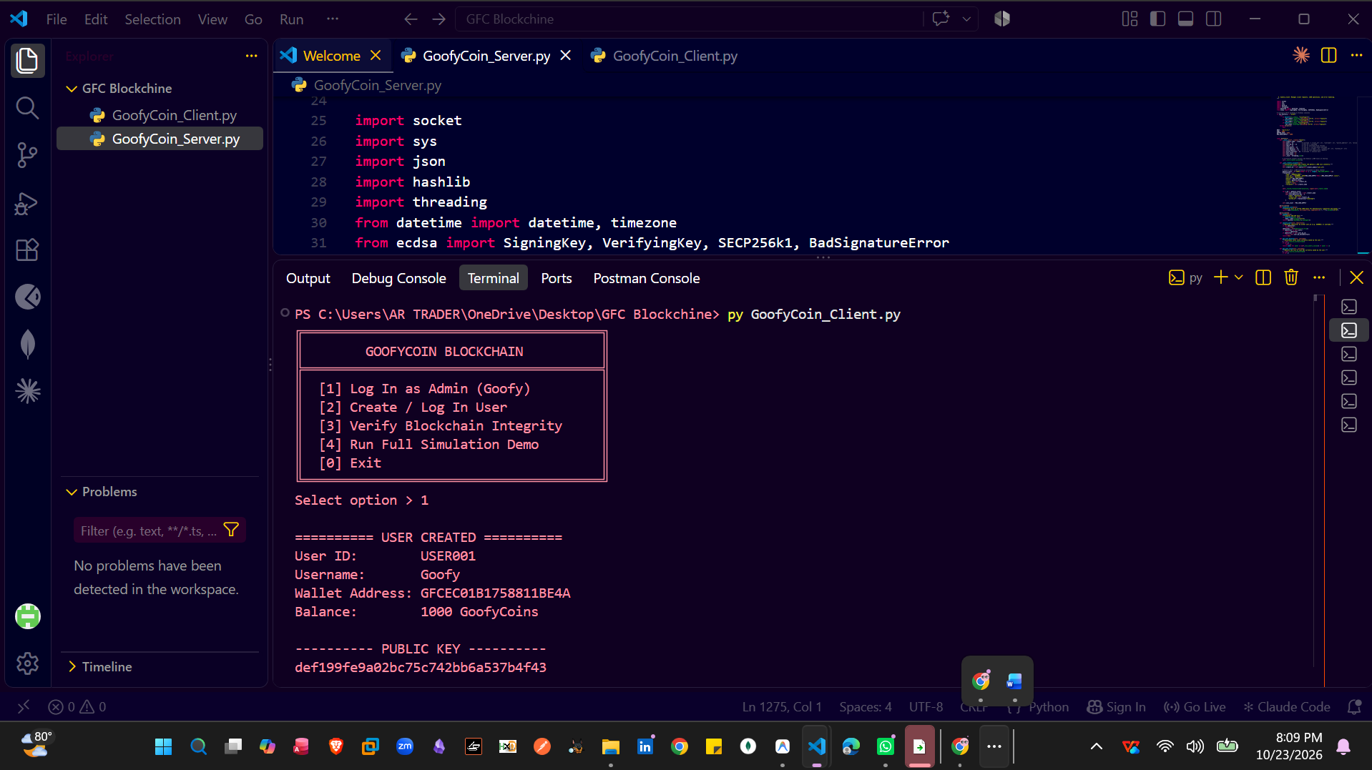
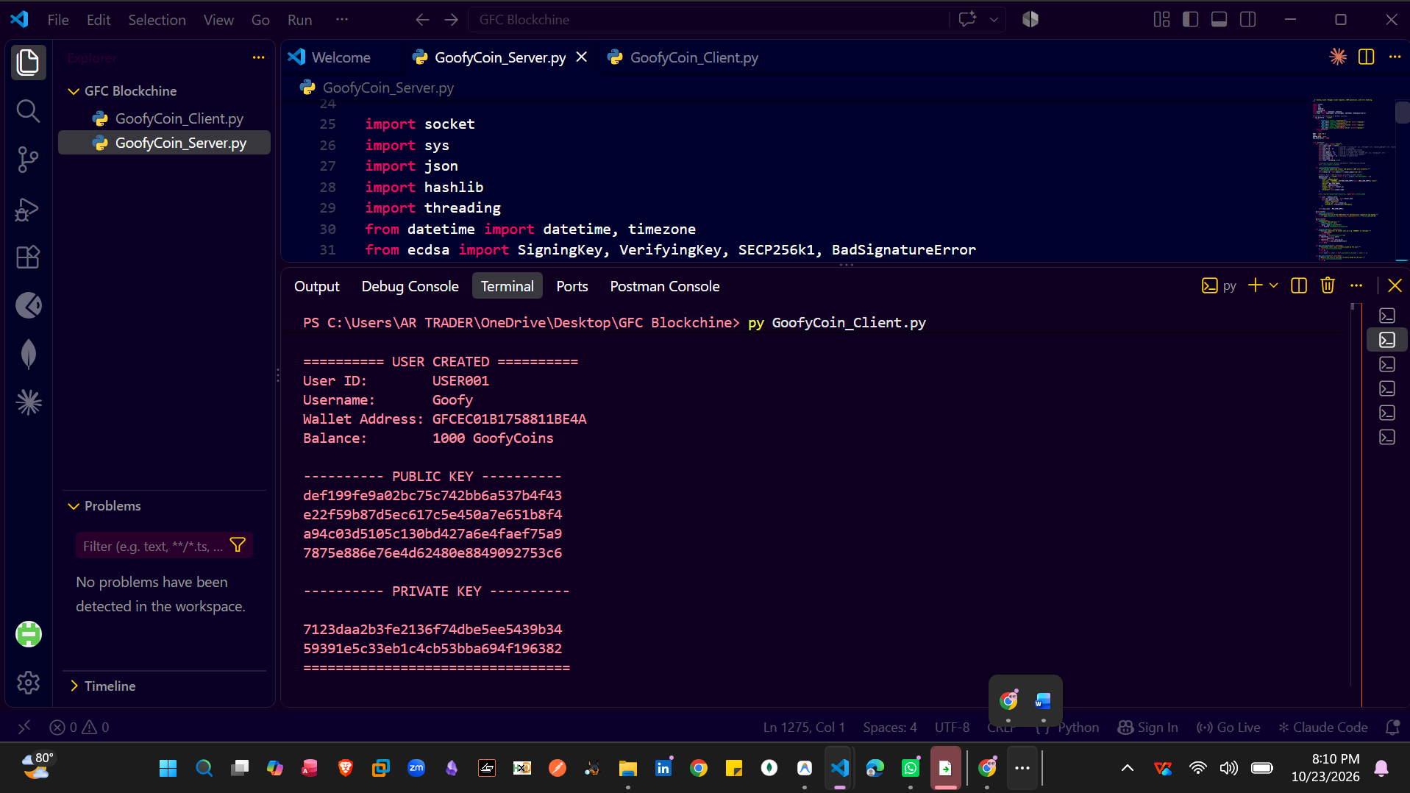

Screenshot 8: GoofyCoin Admin Dashboard
Explanation: In this step, the client displays the GoofyCoin Admin Dashboard after launching the client program. The dashboard shows the total coin supply and options to mint coins, transfer coins, view requests, inspect the blockchain ledger, verify blockchain integrity, and view registered users.
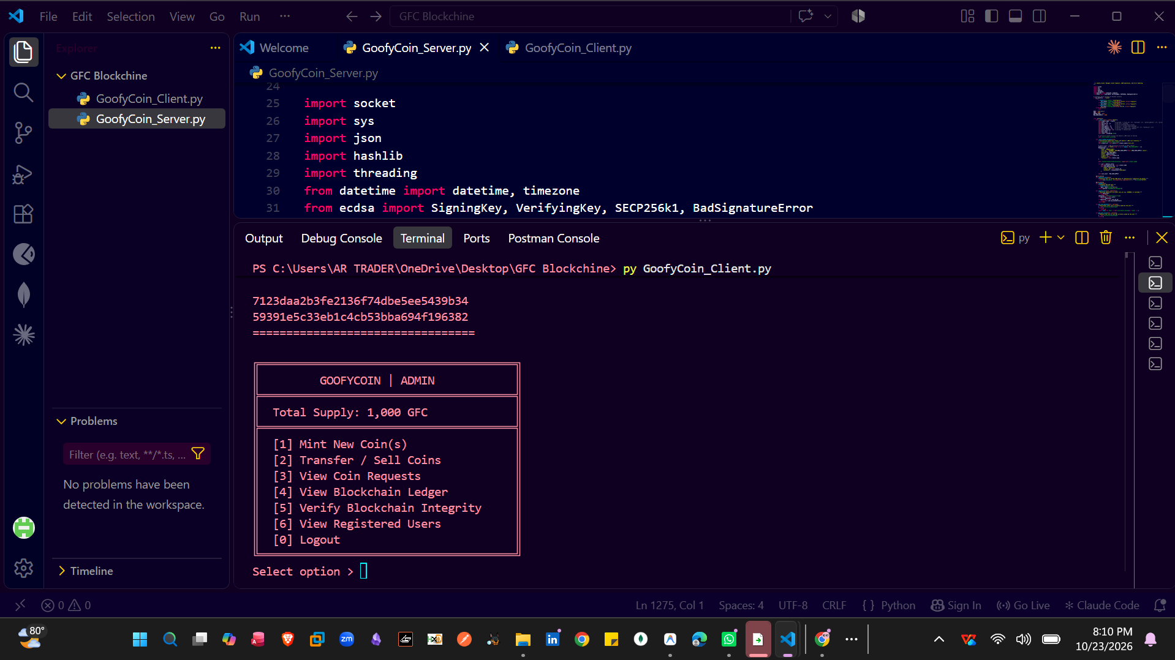

Screenshot 9: Normal Create Users
Explanation: In this step, we use the GoofyCoin client to create new users. The CreateUser() function generates the user's cryptographic key pair and wallet address, allowing the user to participate in coin transactions.

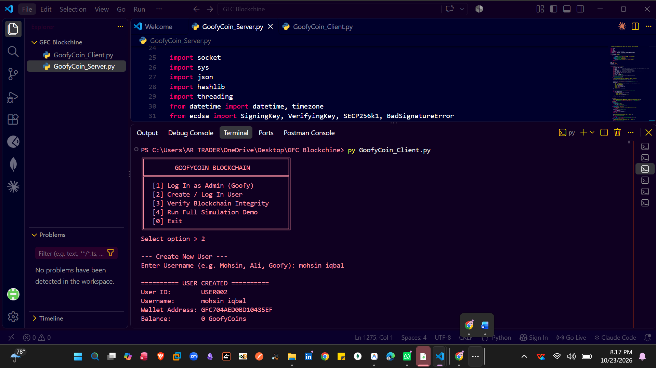
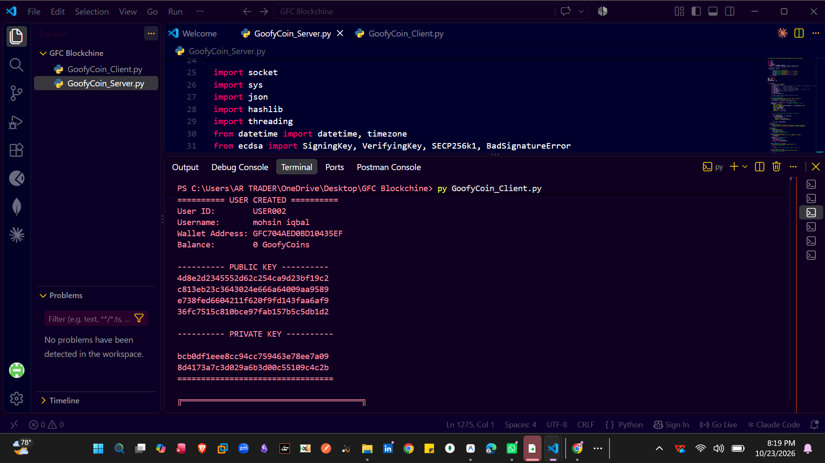

Screenshot 10: Normal User Dashboard
Explanation: In this step, we create and access a normal user account, shown here as USER002. The wallet dashboard displays the user's balance and provides options to view transaction history, request or buy coins, transfer coins, manage requests, and verify blockchain integrity.

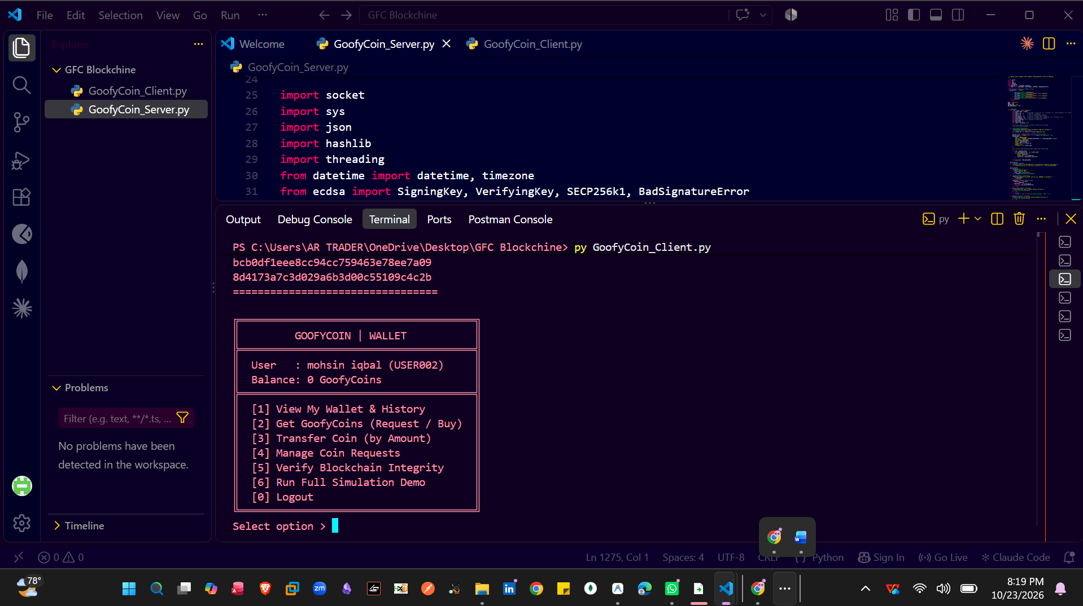

Screenshot : CreateCoin

Screenshot 11: Minting New GoofyCoins
Explanation: In this step, the Admin selects the Mint New Coin(s) option and enters the coin name and quantity to create. The server processes the minting request and records the authorized coin-creation transaction in the blockchain.

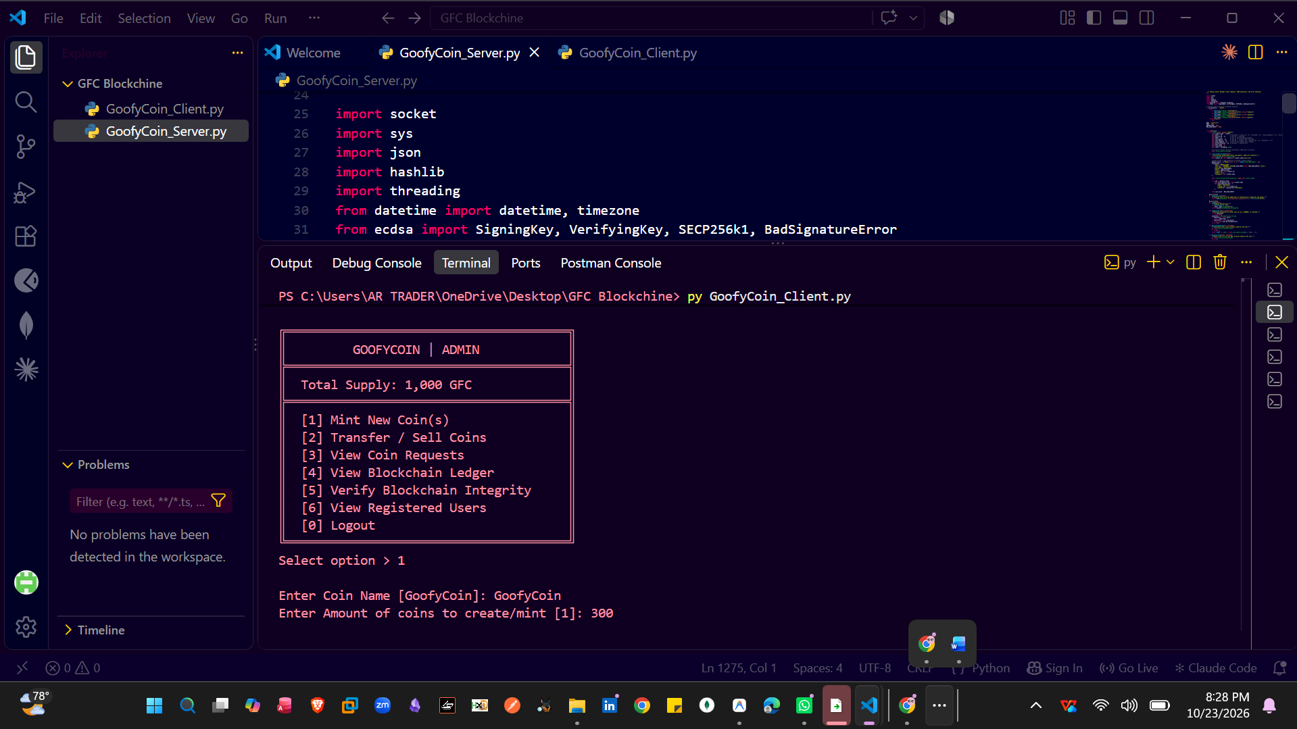

Screenshot 12: Successful Coin Minting
Explanation: In this step, the Admin successfully creates new GoofyCoins by submitting the minting request. The server confirms the operation and records the coin-creation transaction in the blockchain.

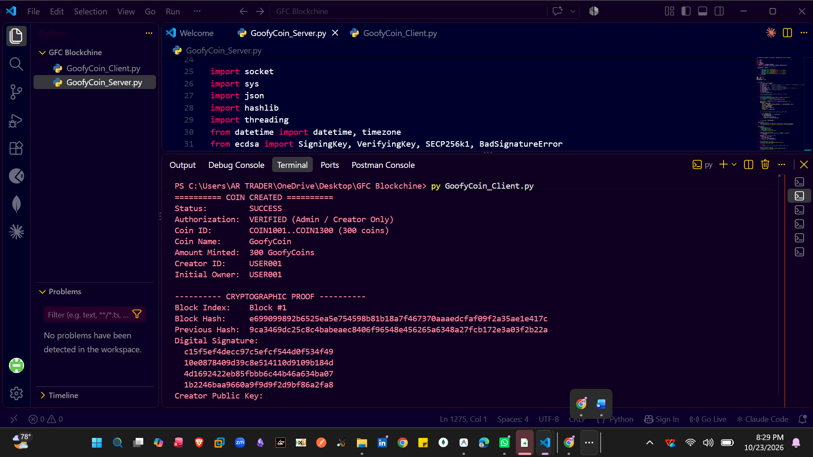

Screenshot 13: Cryptographic Proof of Successful Coin Minting
Explanation: The terminal displays the cryptographic proof of the newly minted coins, including the block index, block hash, previous hash, digital signature, and creator’s public key. It also confirms successful minting and displays the updated admin balance and total coin supply.
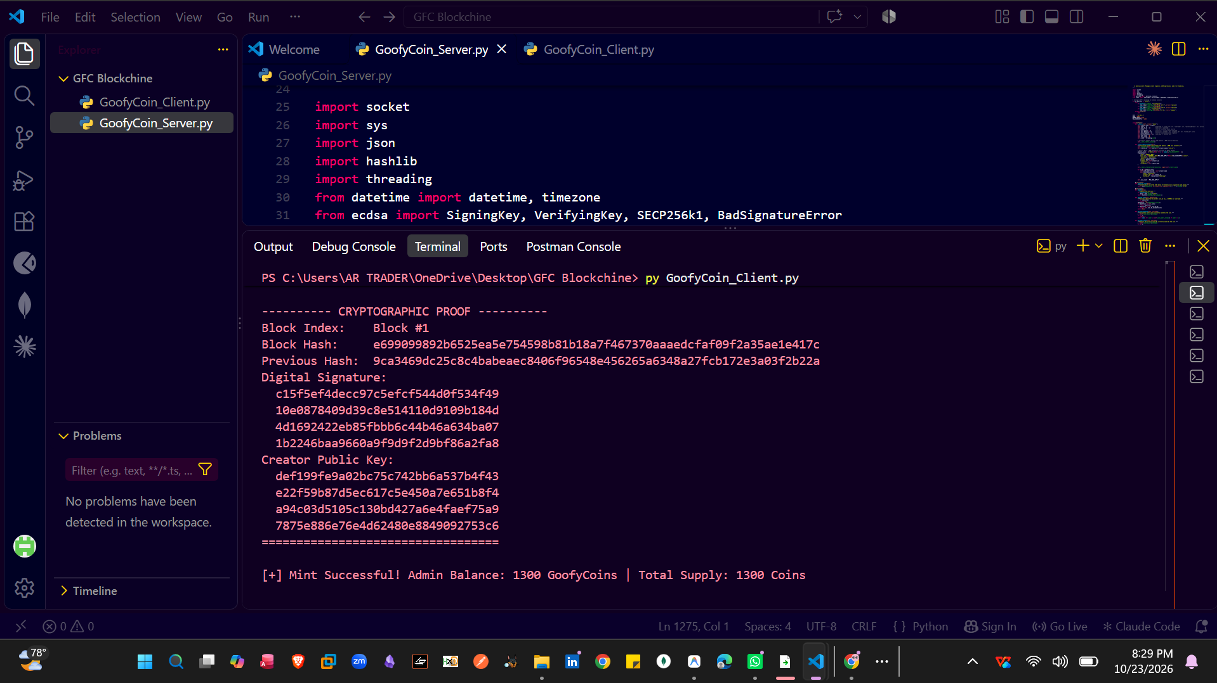

Screenshot 14: Successful Coin Minting and Updated Admin Balance
Explanation: The terminal confirms that the coin-minting operation was successful and displays the updated Admin balance of 1,300 GoofyCoins. The dashboard also reflects the new total supply of 1,300 GFC and returns to the Admin menu for further operations.

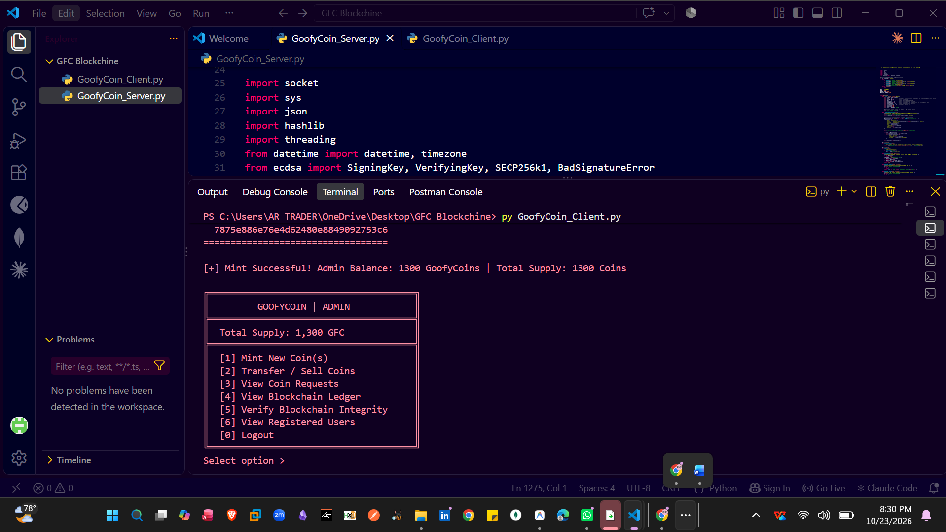

Screenshot : TransferCoin

Coin Purchase Request and TransferCoin Workflow
Explanation: A newly registered user initially has zero coins, so they can submit a purchase request to the Admin or another user who has coins available. The request is reviewed and approved, and the specified amount is released to the buyer’s wallet; the request, approval, and balance update are documented through screenshots on both the Admin and User sides, similar to an order-based purchase workflow.

Screenshot : Admin-to-User Coin Transfer

Screenshot 15: User Coin Purchase Request
Explanation: In this step, the user selects the coin purchase option and chooses an available supplier by name. The user enters the required coin amount and submits an order request, which is sent to the selected supplier for review and approval before the coins are transferred to the buyer’s wallet.

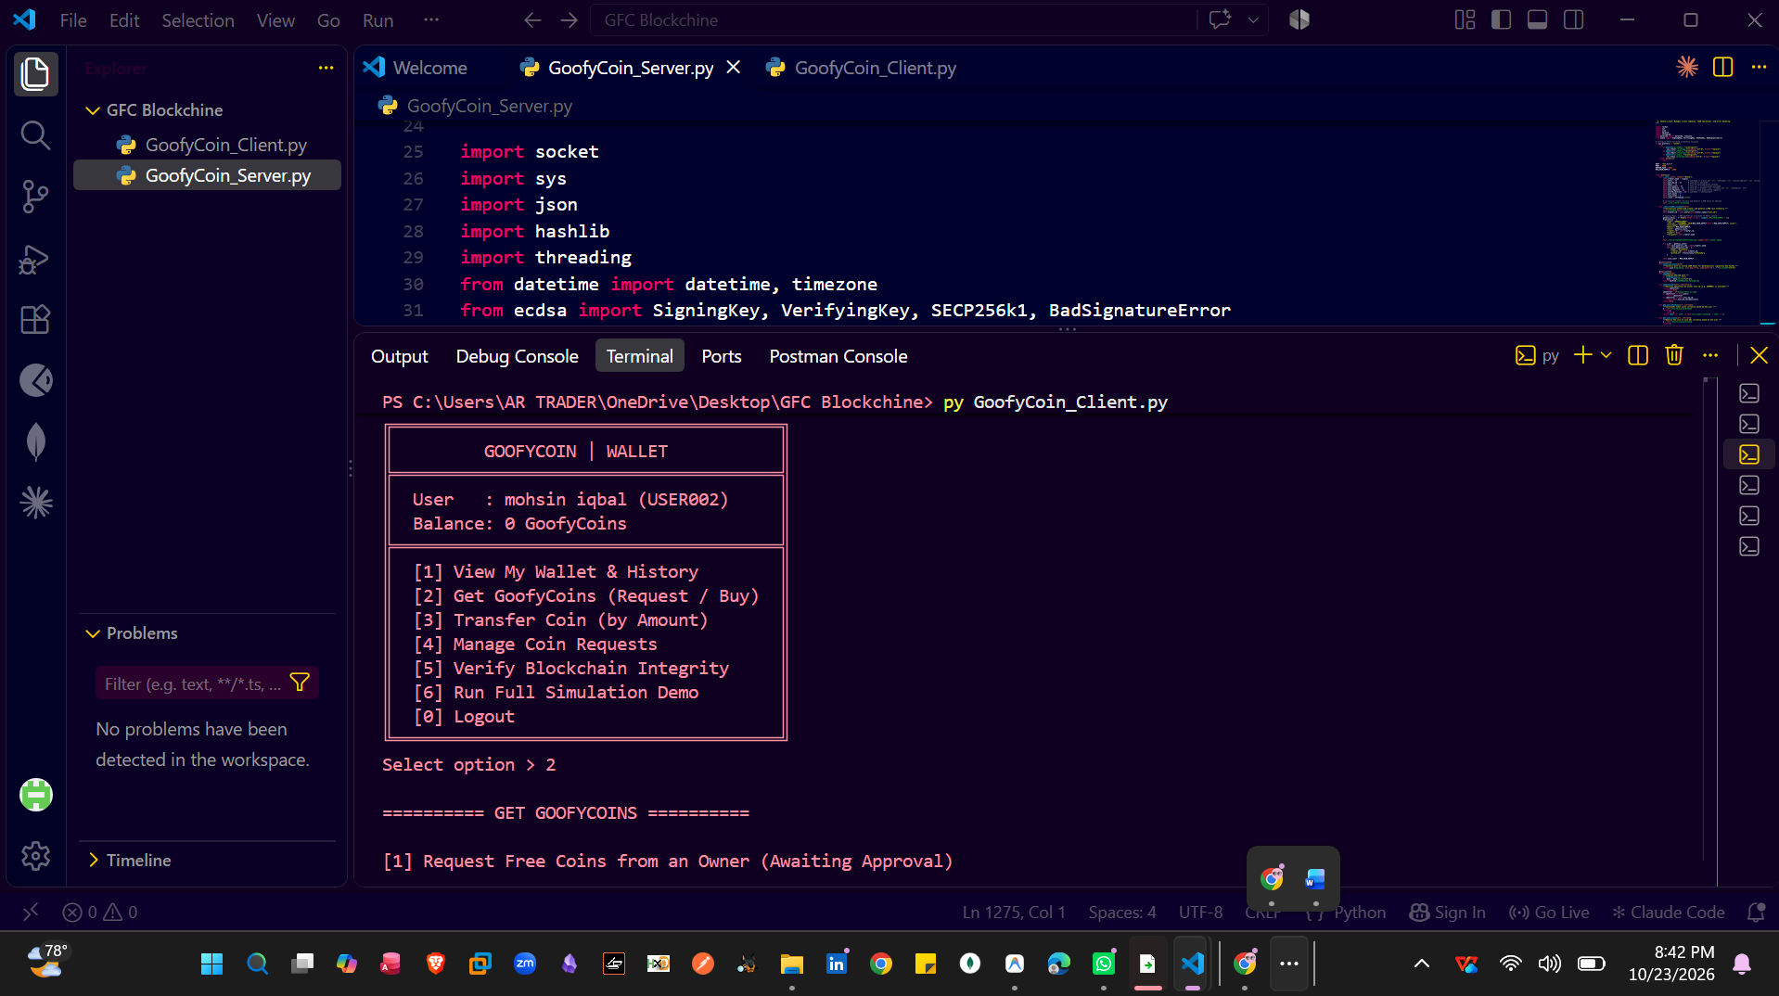

Screenshot 16: Supplier Name Validation
Explanation: In this step, the user submits a coin purchase request without entering the supplier’s name, and the system displays an error. The user must enter a valid supplier name to send the order request to the intended supplier for further processing.

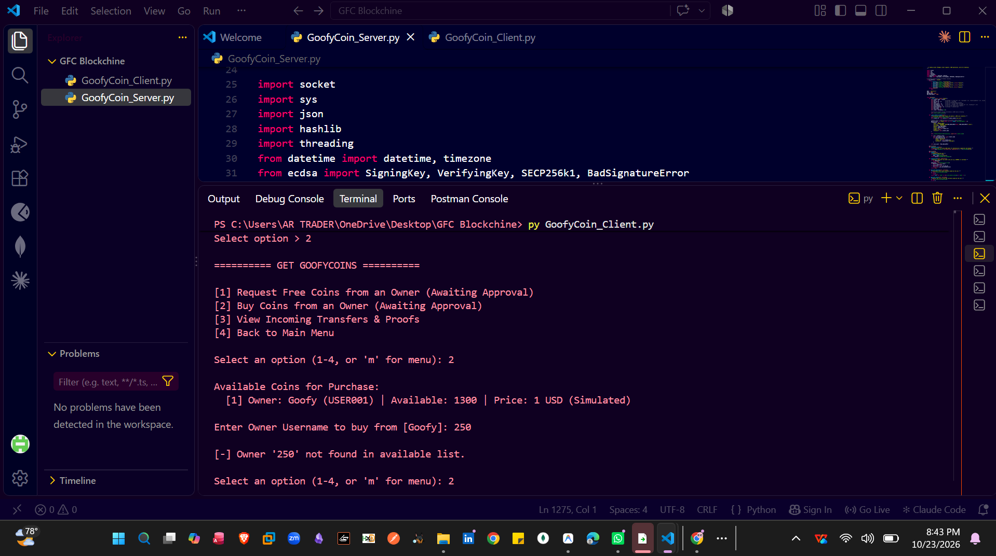

Screenshot 17: Coin Purchase Request Submitted Successfully
Explanation: In this step, the system successfully submits the user's coin purchase request and displays its status as Pending. The request remains pending until the selected supplier or Admin reviews and approves it.

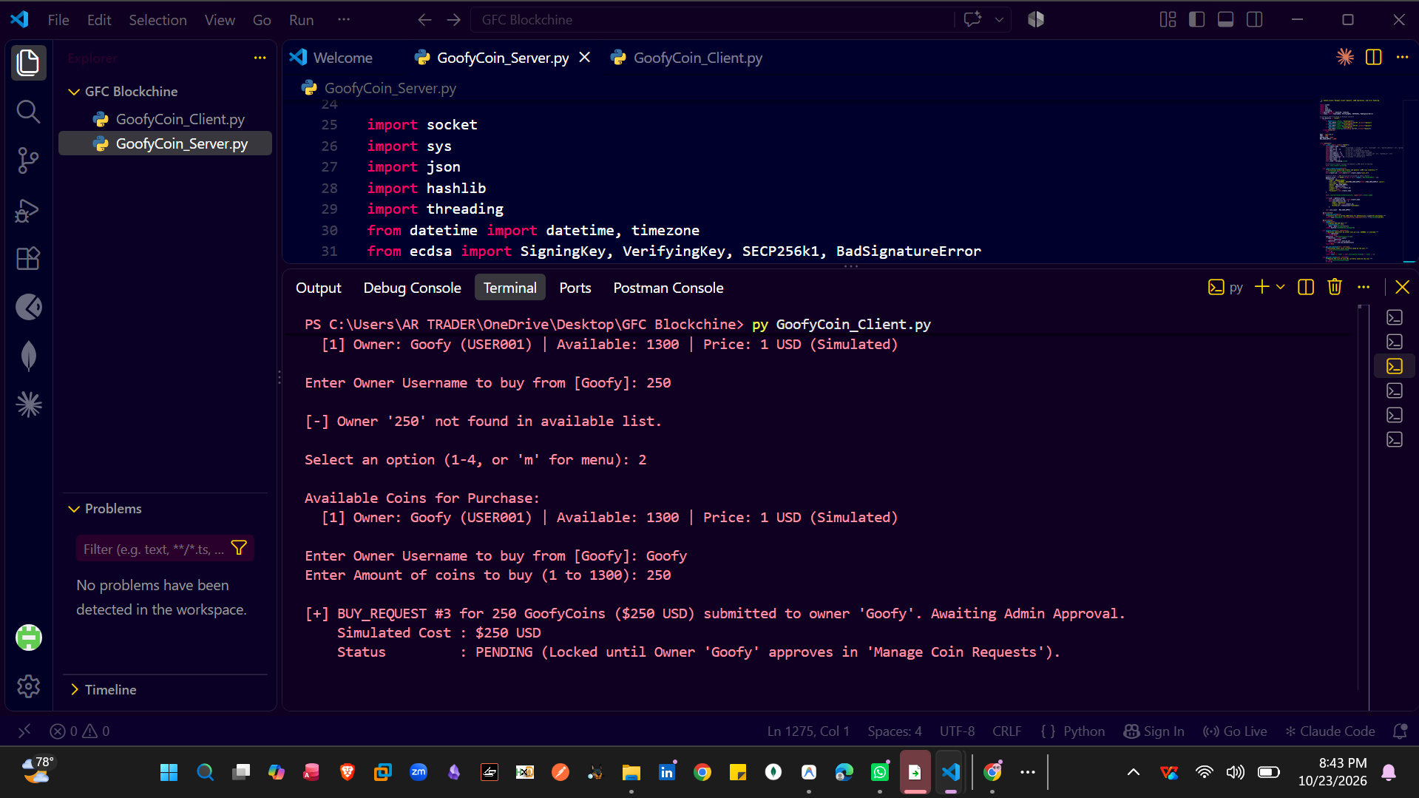

Screenshot 18: Admin Views Pending Coin Purchase Requests
Explanation: In this step, the Admin opens the request management section to view coin purchase orders submitted by users. The Admin reviews each pending request, including the buyer’s details and requested coin amount, before approving or rejecting the order.
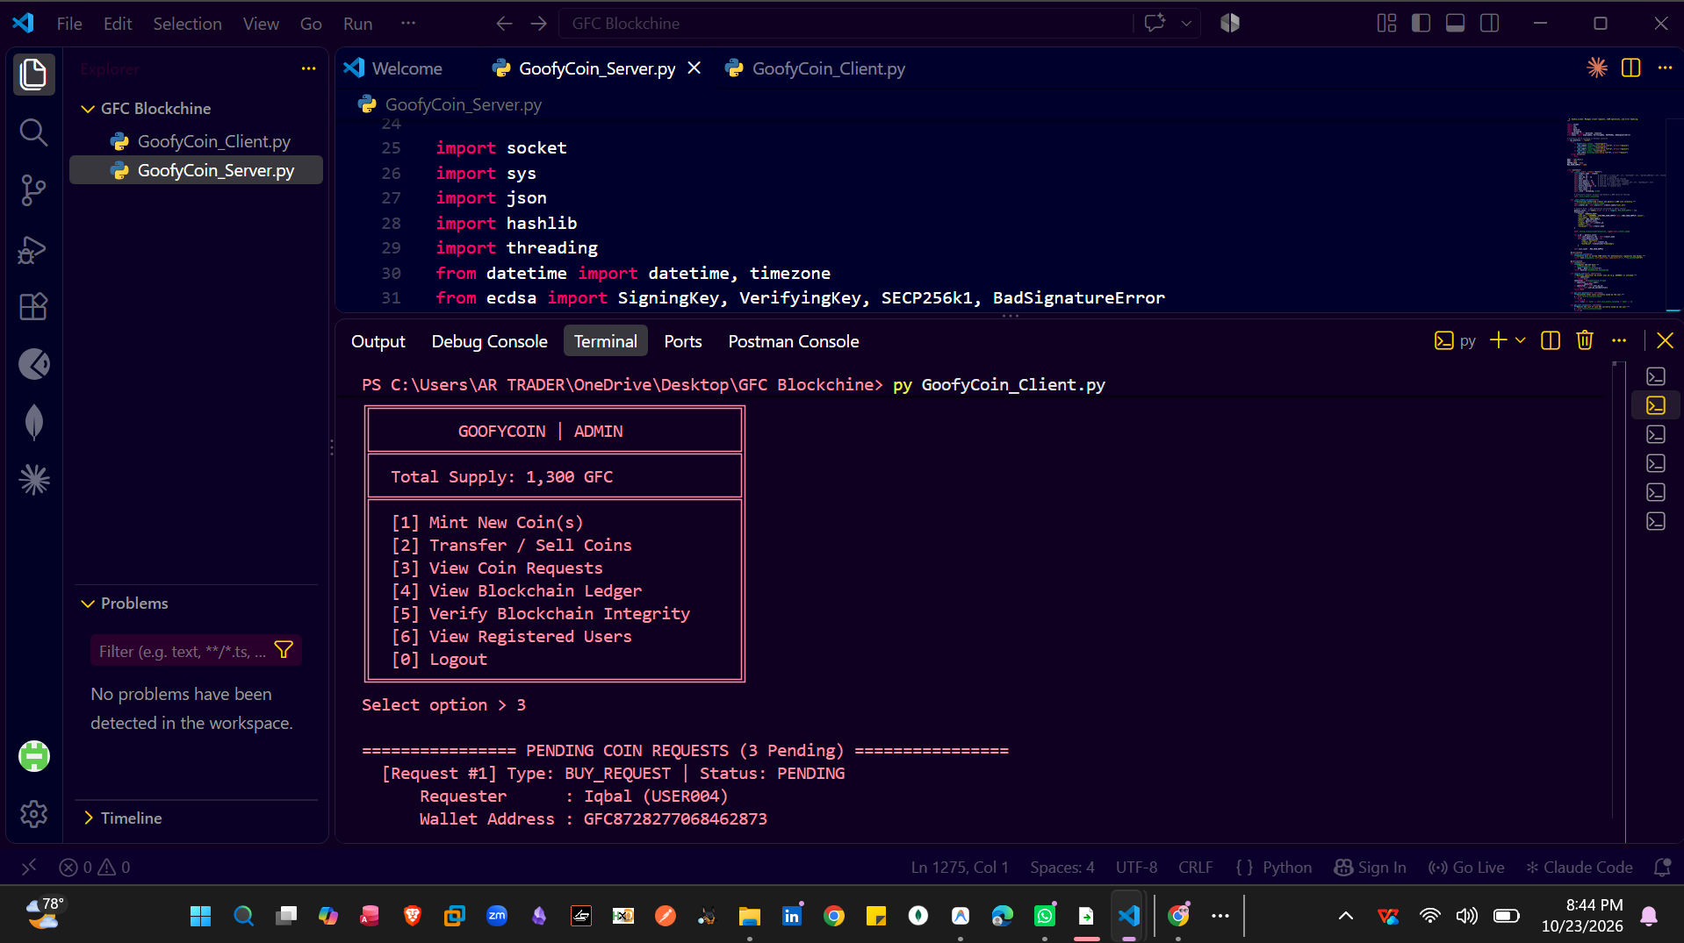

Screenshot 19: Displaying Pending Coin Purchase Orders
Explanation: In this step, the Admin Dashboard displays all pending coin purchase requests submitted by users. The Admin can review each order’s details, including the requesting user and the requested coin amount, before taking further action.

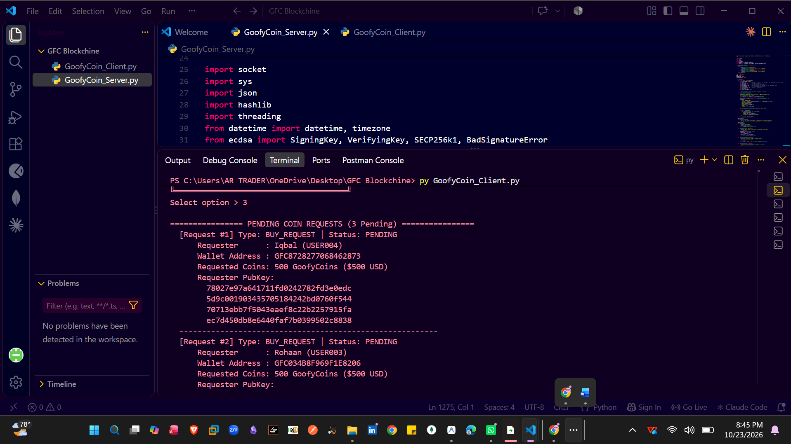

Screenshot 20: Successful Coin Purchase Order Processing
Explanation: In this step, the Admin selects a pending coin purchase request and processes it successfully. The system completes the transaction, updates the relevant coin balances, and changes the order status to reflect successful processing.

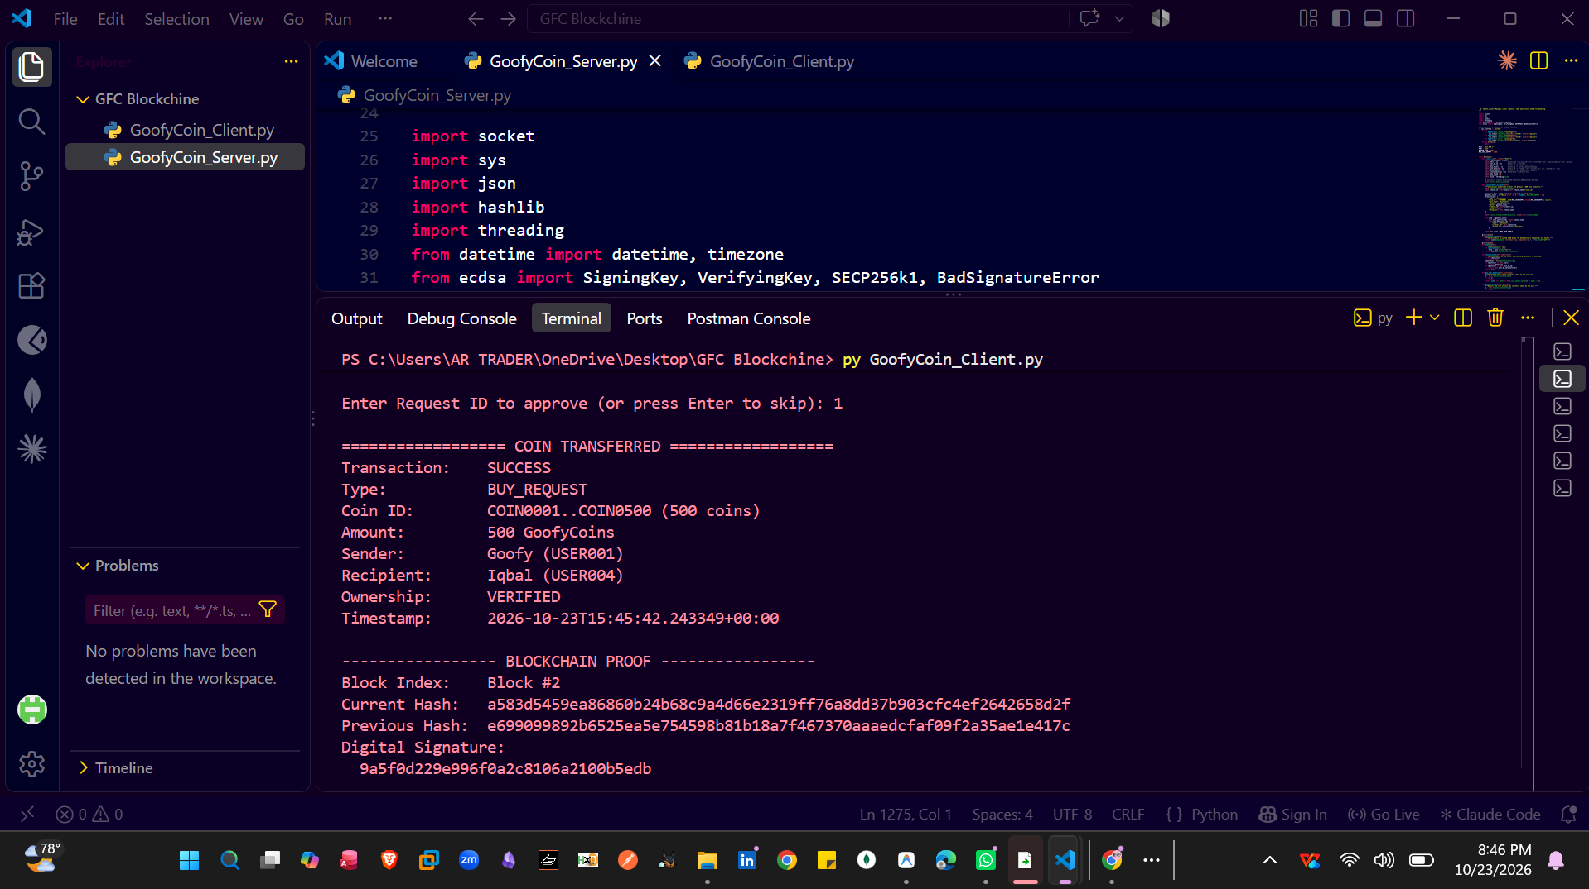

Screenshot 21: Blockchain Proof of Successful Coin Transfer
Explanation: In this step, the system displays the blockchain proof of the successful transaction, including the digital signature, sender’s cryptographic details, and recipient’s hash information. These details help demonstrate transaction authenticity and support the verification of blockchain integrity.

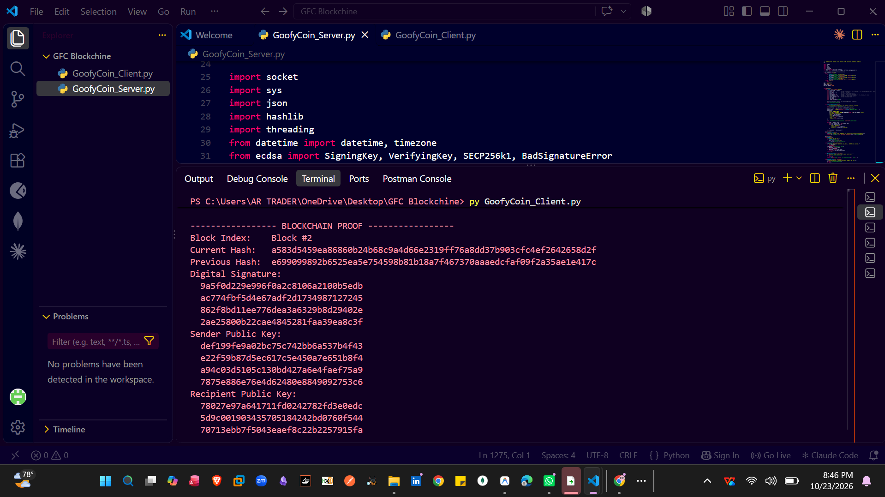

Screenshot 22: Successful Coin Purchase Request Approval
Explanation: In this step, the Admin successfully approves Request #1 (BUY_REQUEST), transferring 500 GoofyCoins to the user named Iqbal. The terminal confirms the successful transaction and displays the recipient’s public key as part of the transaction details.

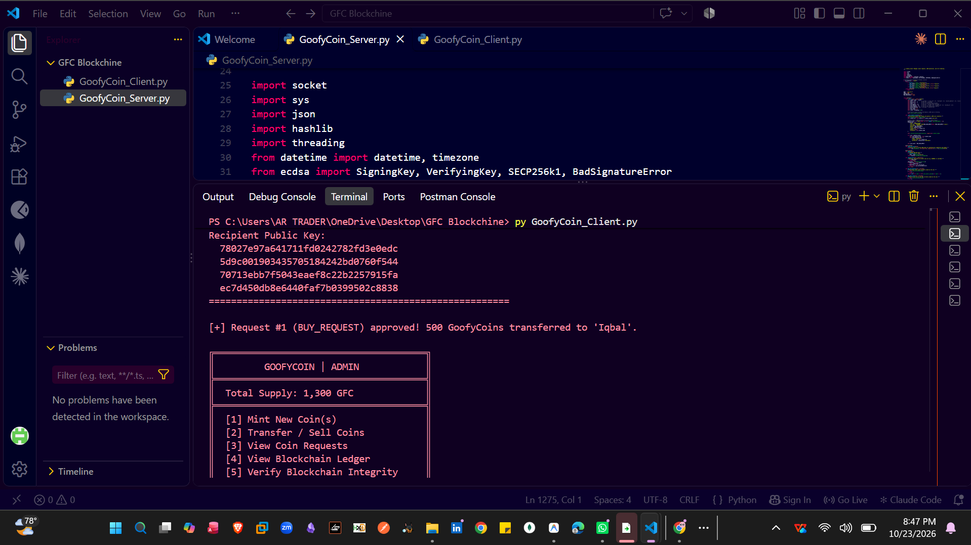

Screenshot : User-to-User Coin Transfer

Screenshot 23: User-to-User Coin Transfer and Error Handling
Explanation: This step demonstrates how a user transfers GoofyCoins to another user by entering the recipient’s User ID and the transfer amount. It also shows error handling when the entered User ID or transfer details are invalid.
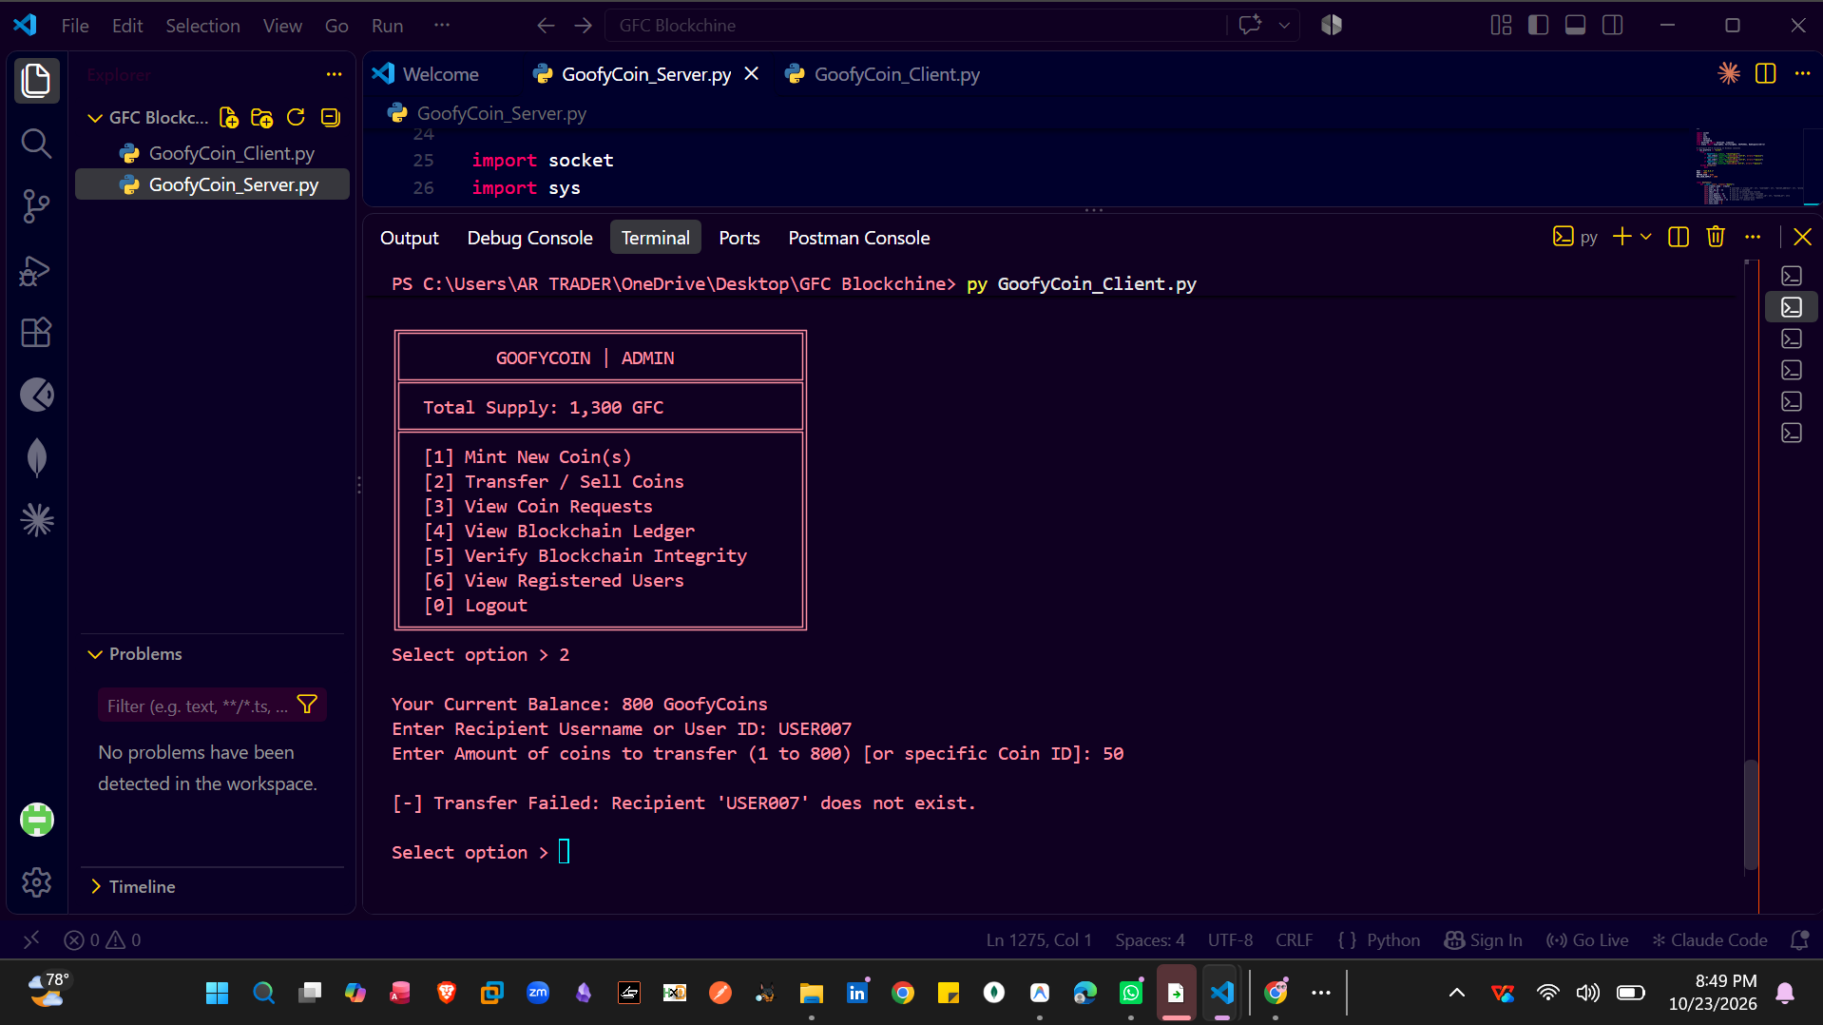

Screenshot 24: User-to-User Transfer and Error Handling
Explanation: The screenshot shows an unsuccessful transfer because the recipient ID USERE007 does not exist, followed by a successful transfer of 39 GoofyCoins from USER001 to USER003. The successful transaction displays the sender, recipient, ownership verification, timestamp, and blockchain proof.

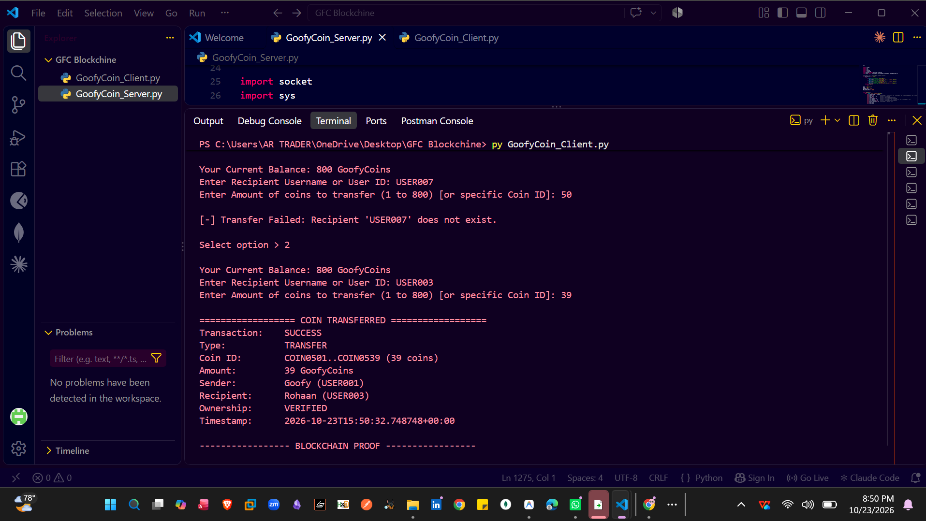

Screenshot 25: Blockchain Proof of Successful Coin Transfer
Explanation: This screenshot displays the cryptographic proof of a successful user-to-user coin transfer, including the block index, current hash, previous hash, digital signature, and sender’s and recipient’s public keys. The system confirms the transfer and displays the sender’s updated balance of 761 GoofyCoins.

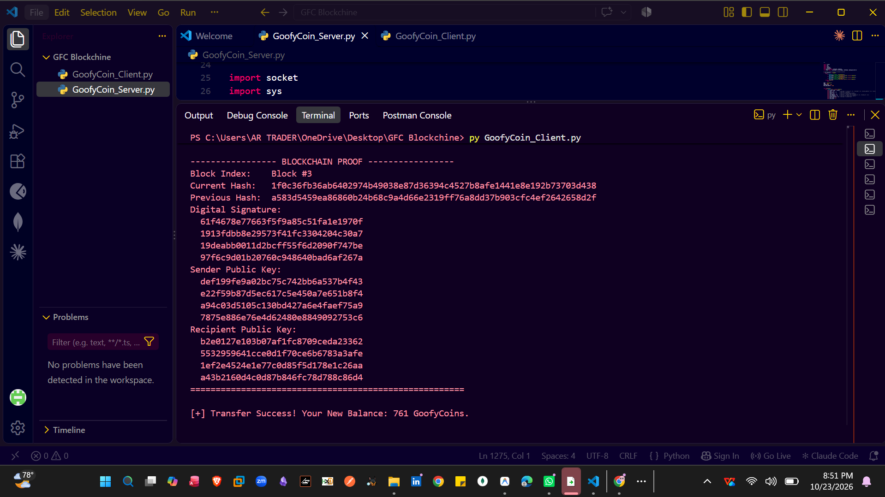

Screenshot 26: Viewing Available Coin Suppliers
Explanation: In this step, the new user can view all available coin suppliers, including their usernames, available coin balances, and simulated prices. The user selects a supplier by entering their username to initiate a coin purchase request, which will require approval before the coins are transferred.

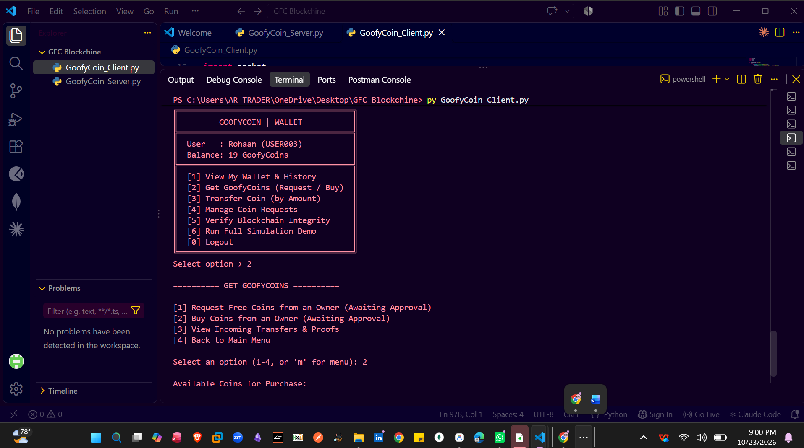
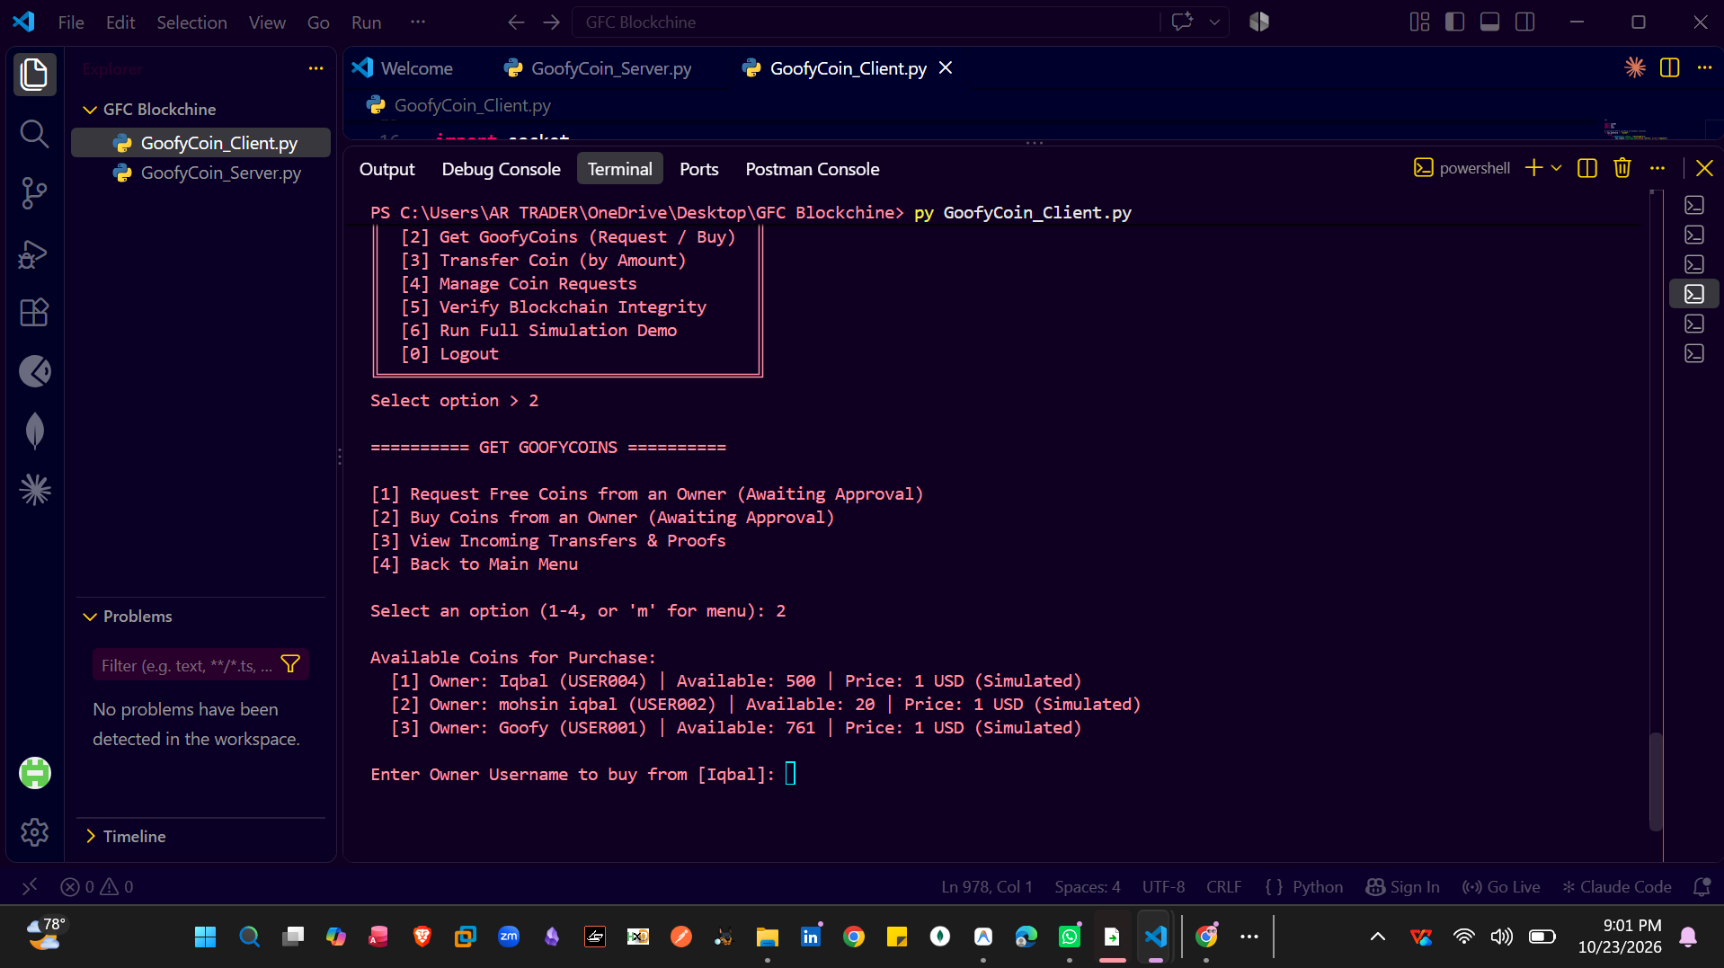

Screenshot : Verify_chain

Screenshot 27: Viewing Blockchain Ledger and Transaction History
Explanation: In this step, the user views the blockchain ledger to review recorded transactions and their details. The transaction history helps track coin transfers, including sender and recipient information, amounts, timestamps, and associated blockchain records.

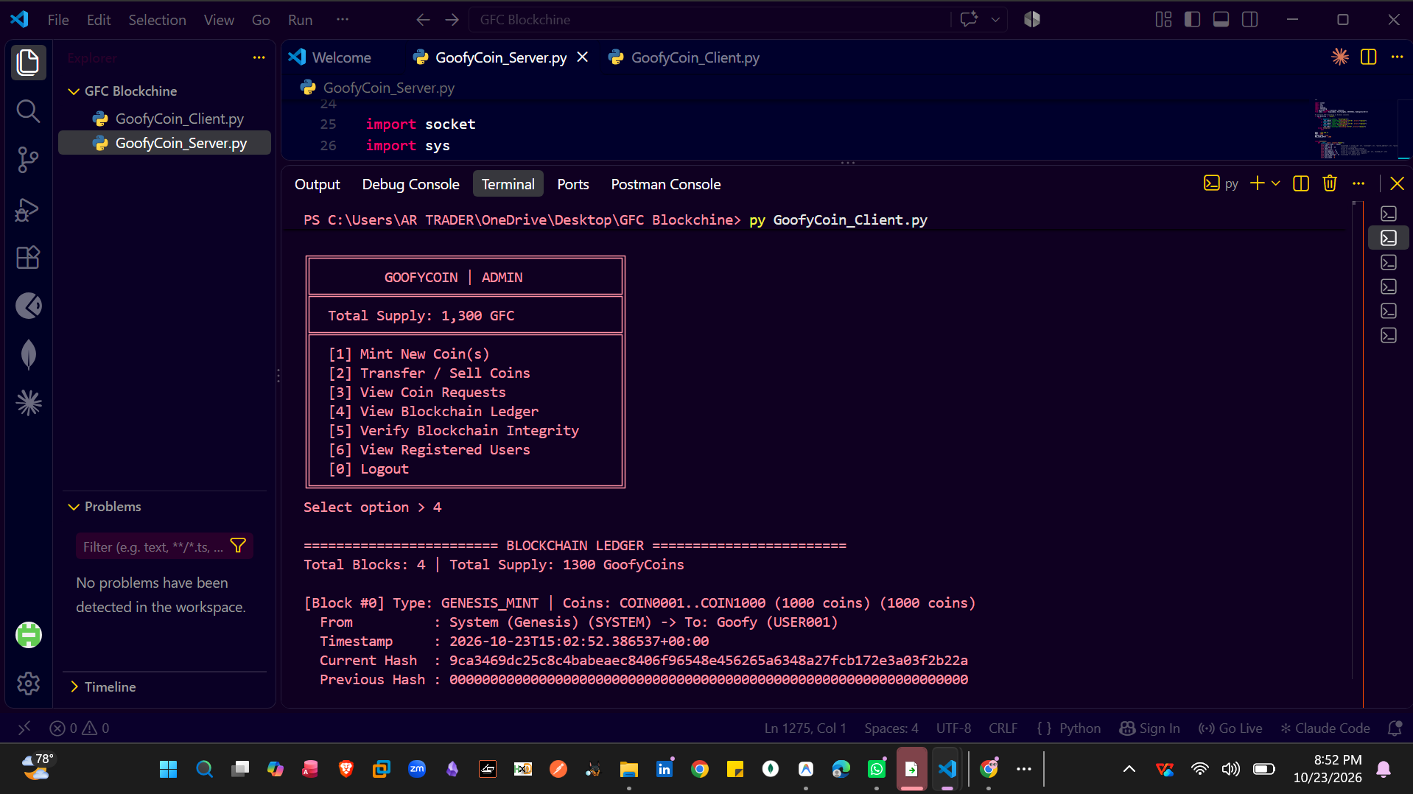
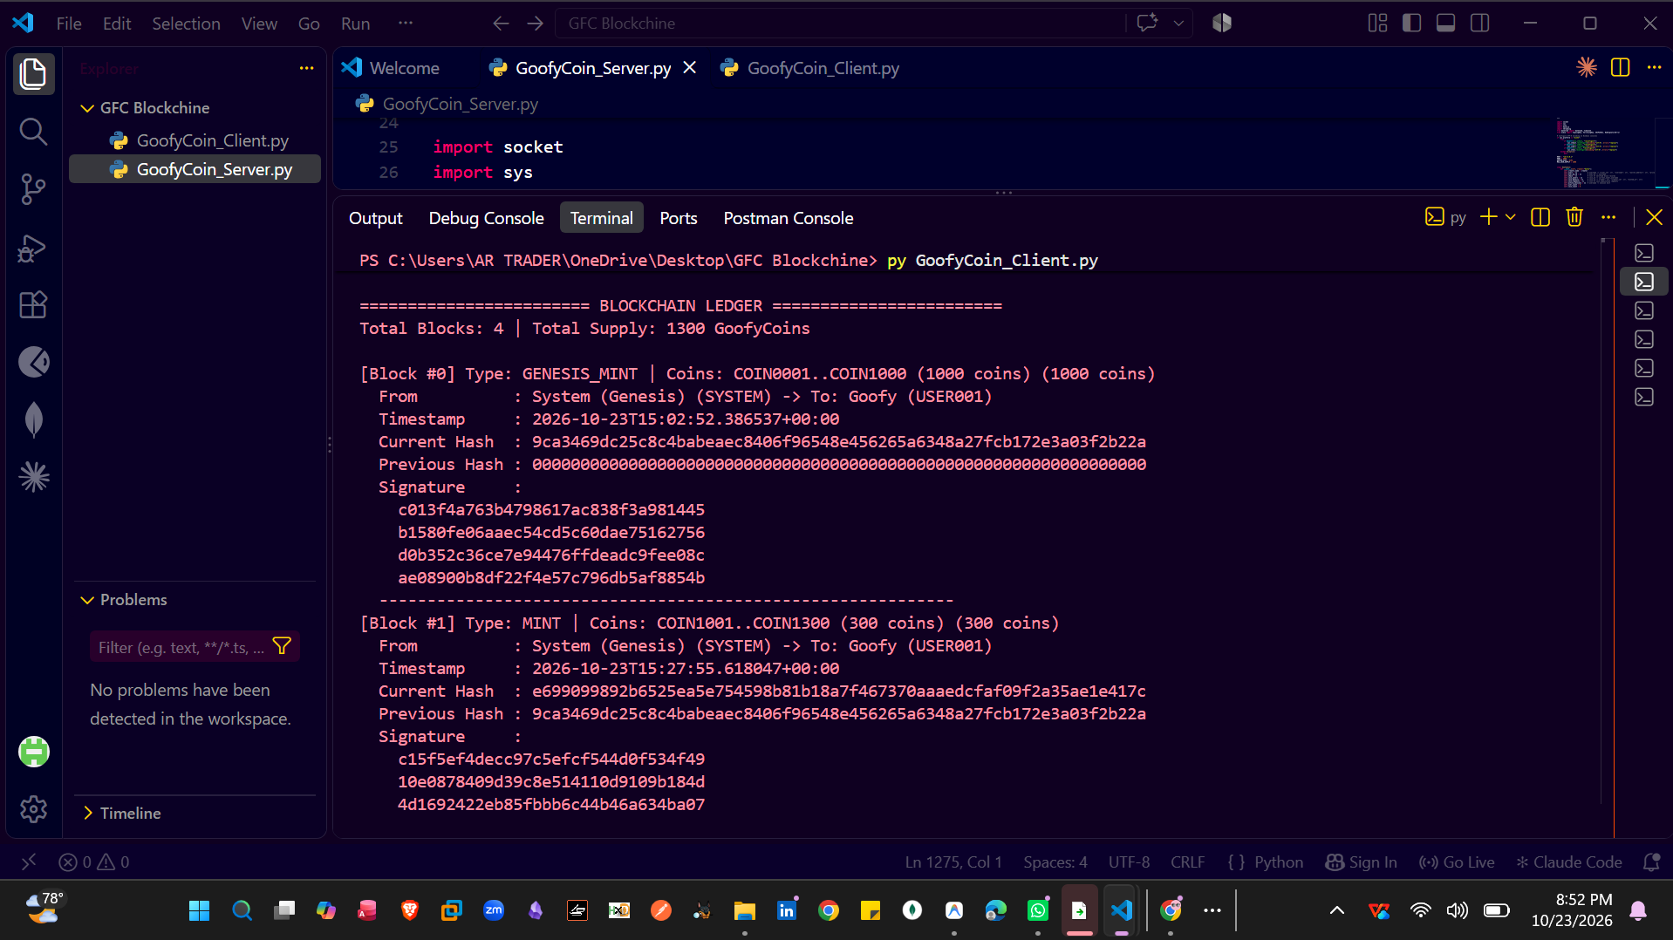
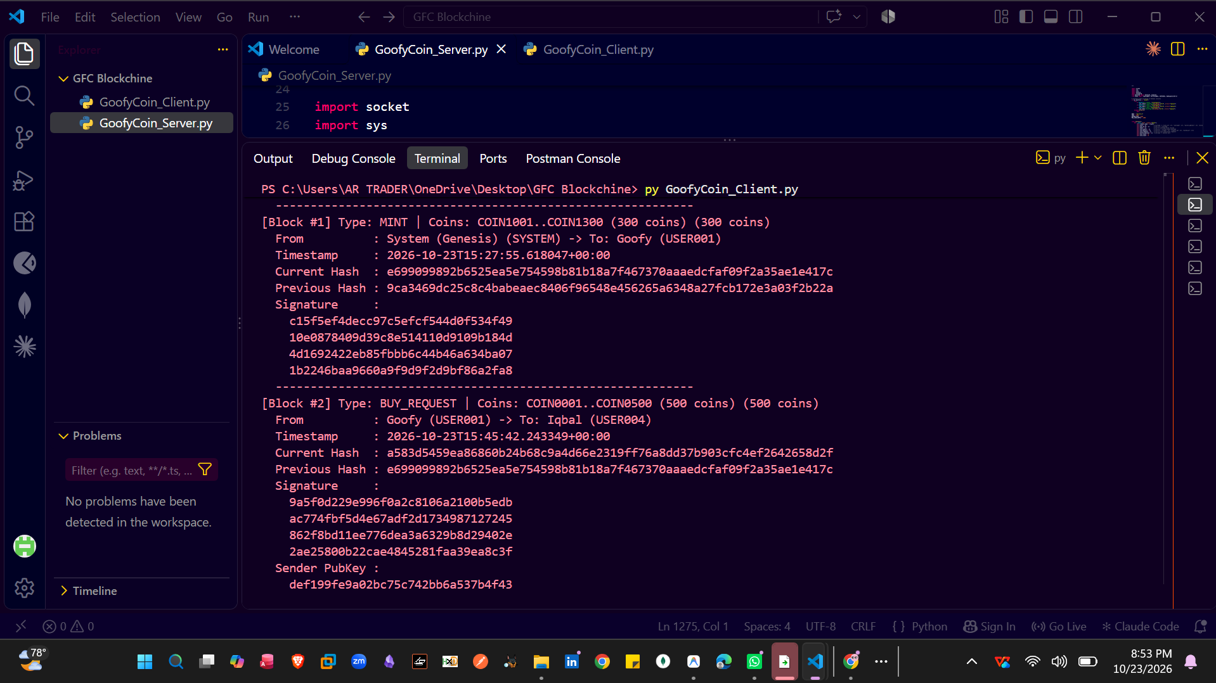
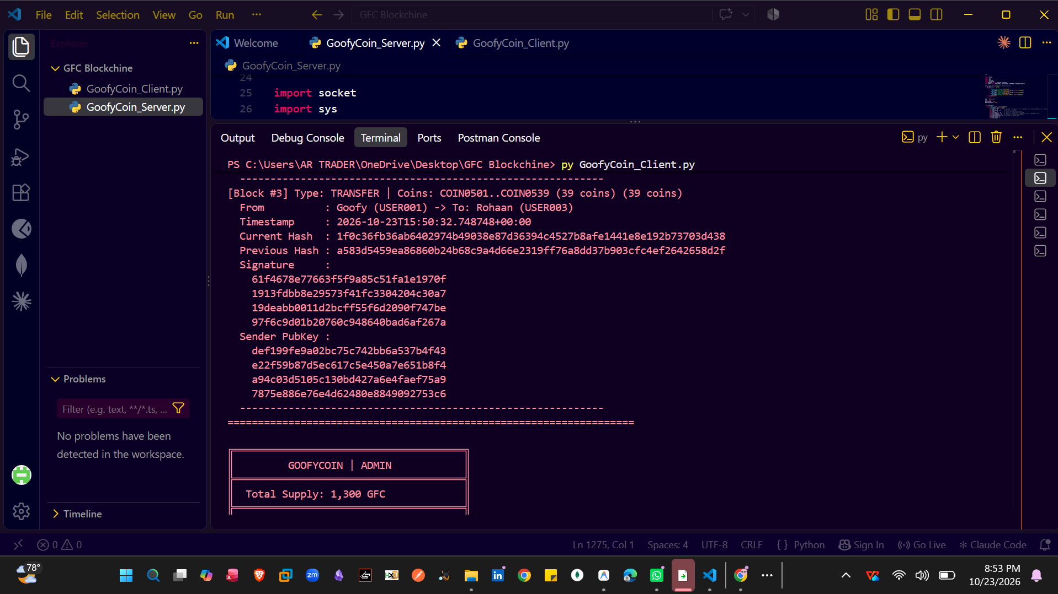

Screenshot 28: Blockchain Integrity Verification
Explanation: In this step, the Admin runs the blockchain verification process, and the system validates the block structure, hashes, digital signatures, coin ownership, and transaction history. The results show BLOCKCHAIN VALID, with no tampering detected and a verified network supply of 1,300 GoofyCoins.
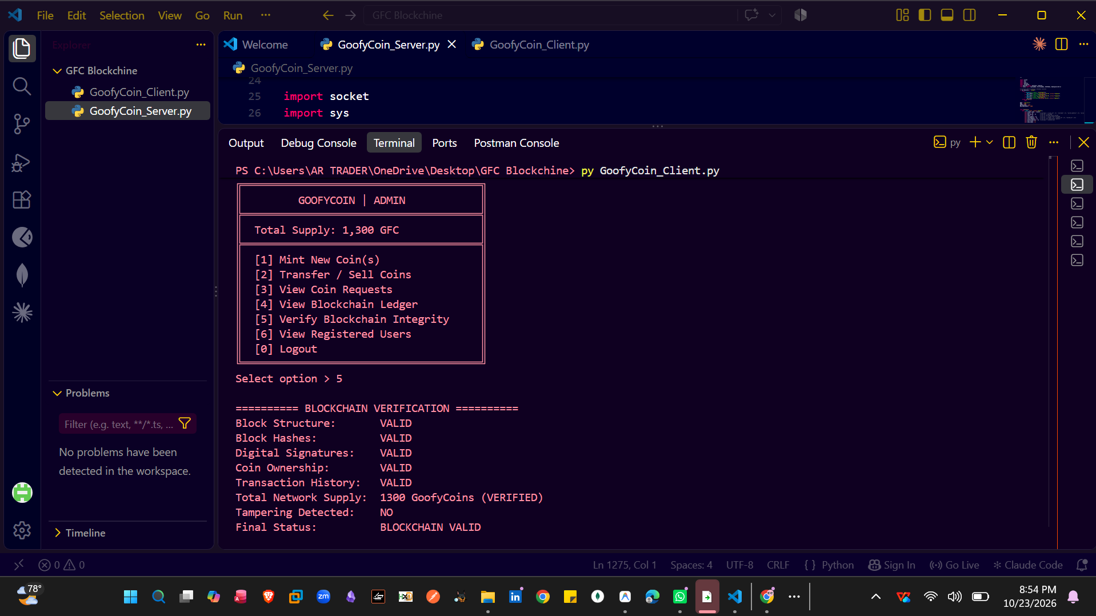

Screenshot : start_server

Screenshot 29: start_server() Function Server Initialization
Explanation: The start_server() function creates the TCP server, binds it to the configured host and port (127.0.0.1:5000), and listens for incoming client connections. It starts the server-side communication process so clients can send requests and interact with the GoofyCoin blockchain.
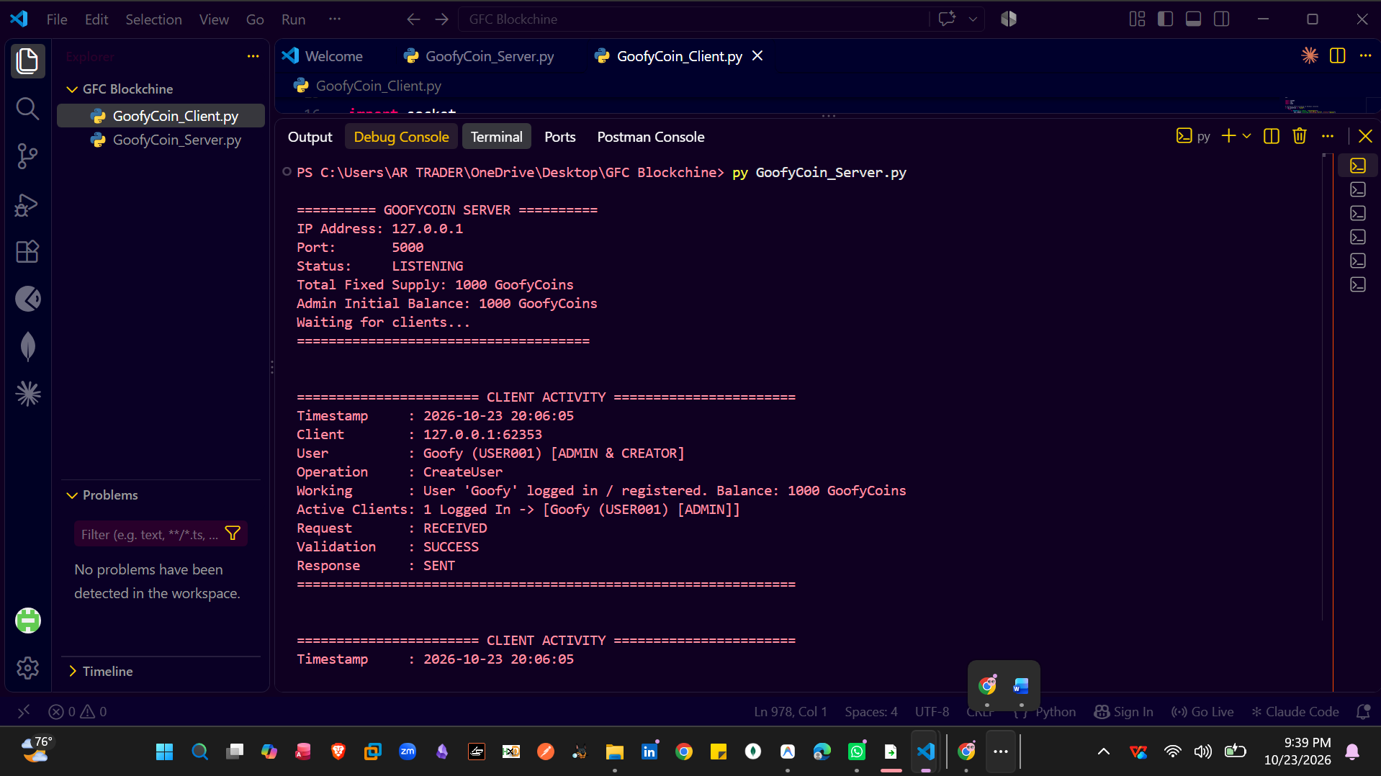

Screenshot 30: Server-Side Client Activity Logging
Explanation: This screenshot shows the server monitoring client activities, including user details, requested operations, wallet balance checks, and available coin suppliers. The logs record incoming requests, validation results, and responses sent back to the client, demonstrating the server’s request-handling process.

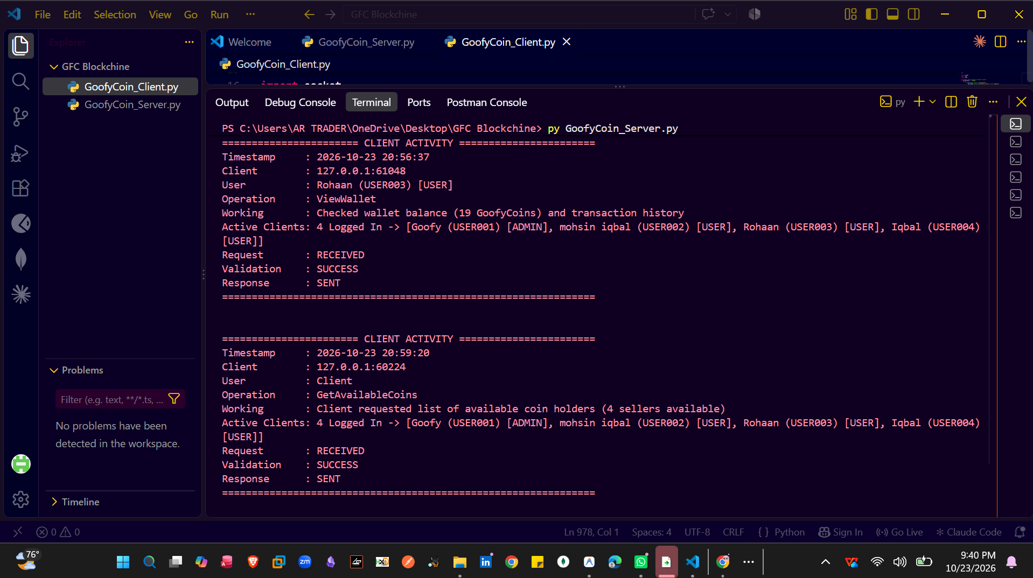

Screenshot : handle_client

Client-Side Working and VS Code Setup
Explanation: Screenshots 7 onward represent the client-side working of the GoofyCoin project, including Admin and User dashboards, coin purchase requests, transfers, transaction history, and blockchain verification. The client is set up in VS Code using GoofyCoin_Client.py and runs in a separate terminal while the server is active, communicating through the configured TCP host and port.

Screenshot 31: handle_client() Function — Client–Server Communication
The handle_client() function handles incoming client requests, processes JSON data, and sends responses back to the client. It connects the client-side operations with the server-side blockchain functions, enabling user registration, coin transfers, and blockchain verification.
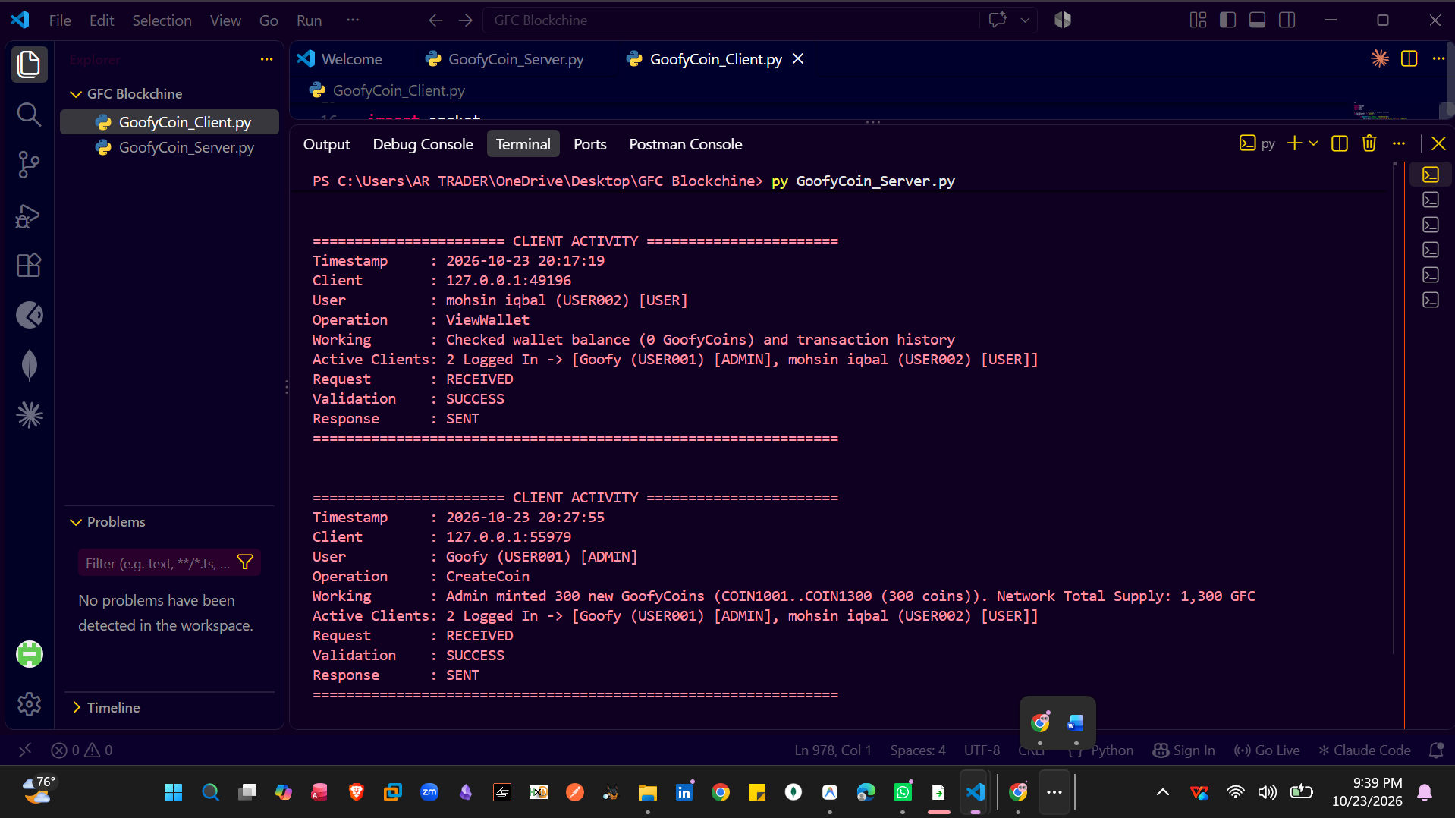

13. How to Run in Visual Studio Code
Install Python 3 and open the folder containing both Python files in VS Code.
Open the integrated terminal: Terminal → New Terminal.
Install the ECDSA dependency: python -m pip install ecdsa
Start the server in Terminal 1 using the actual server filename.
Start the client in Terminal 2 using the actual client filename.
Use the client menu to create users, perform transactions, attempt an unauthorized transfer, and run verification.

14. Conclusion
The submitted GoofyCoin project demonstrates the main educational components of a blockchain application: user key generation, signed transactions, SHA-256 block hashes, previous-hash linking, ownership checks, a TCP server, and an interactive client wallet. The server and client divide the work between maintaining state and presenting operations to the user. Before final submission, the student should run the test plan, add genuine screenshots, and address the fixed-supply enforcement gap identified in this review.
Appendix A Short Glossary
Term | Simple meaning
Blockchain | A sequence of records where each block is linked to the previous block by a hash.
ECDSA | A public-key digital-signature method used to sign and verify transaction data.
Private key | Secret key used to create signatures; it must remain confidential.
Public key | Key used by others to verify a digital signature.
Hash / SHA-256 | A fixed-length digest used to detect changes in data.
TCP socket | A network endpoint used to send and receive data between client and server.
Genesis transaction | The initial transaction that creates and assigns the first coins.
Double spending | Attempting to spend the same coin more than once or transfer a coin without ownership.

